**Napoles, Reyson L.**

**Polytechnic University of the Philippines – Ragay Campus**

**HandsMen Threads: Elevating the Art of Sophistication in Men's Fashion**

**Abstract**

The **HandsMen Threads CRM** is a Salesforce-based system designed to streamline key operations in a men’s fashion business, including customer management, orders, product cataloging, and inventory tracking. It automates essential processes through Flows, Email Alerts, and Validation Rules, improving accuracy and efficiency. The system supports the brand’s goal of delivering a sophisticated, personalized customer experience while providing real-time insights for better business decisions.

**Objectives**

The primary objective of the HandsMen Threads CRM is to;

* **Centralize customer information** to improve customer management and deliver personalized service.
* **Streamline order processing and inventory tracking** to reduce manual work and ensure accurate, real-time updates.
* **Automate key workflows** such as confirmations, stock updates, and loyalty tracking to increase efficiency and minimize errors.
* **Enhance decision-making** through organized data, dashboards, and reports that provide insights into sales and product performance.
* **Strengthen the brand’s sophisticated customer experience** by ensuring smooth, fast, and reliable interactions across all touchpoints.

**Project Phases**

**Phase 1:** **Architecture & Planning**

**Custom Object Creation**

**5 custom Object are created to store in Business-critical data**

* HandsMen Customer
* HandsMen Product
* HandsMen Order
* Inventory
* Marketing Campaign

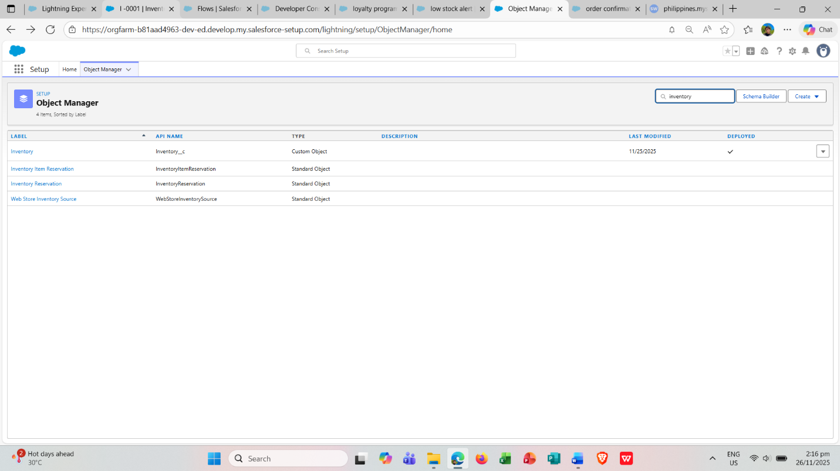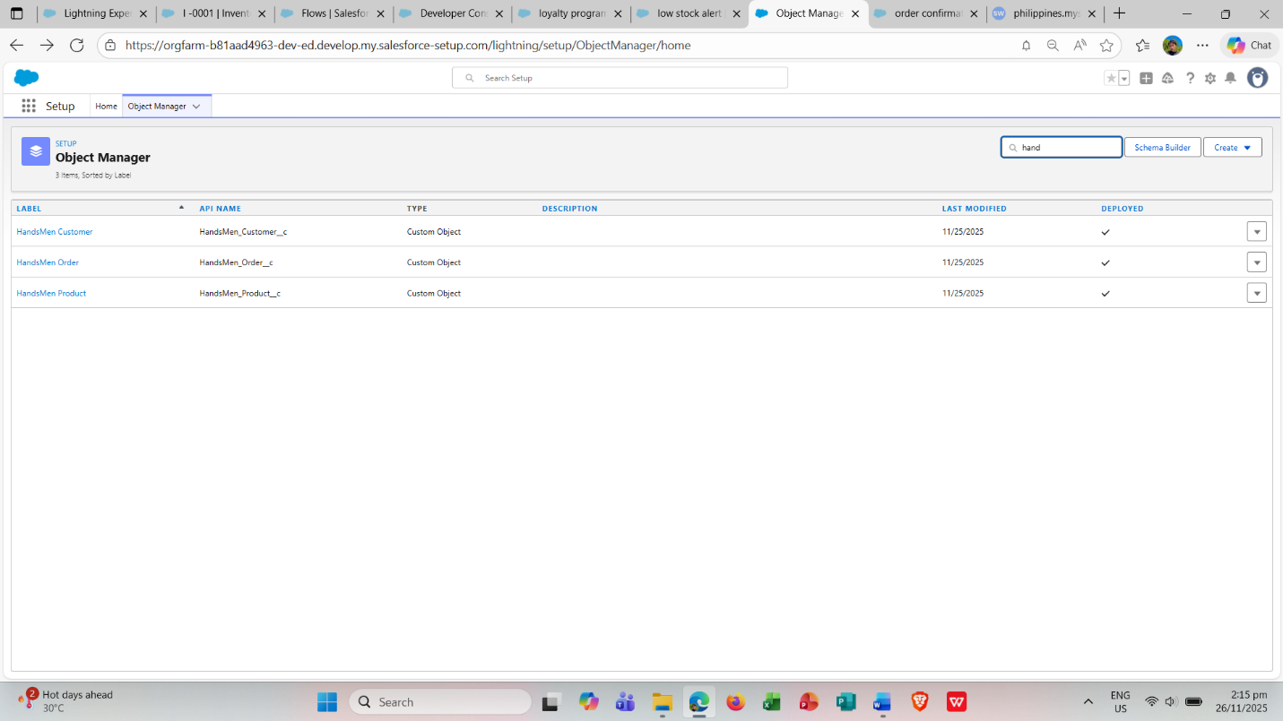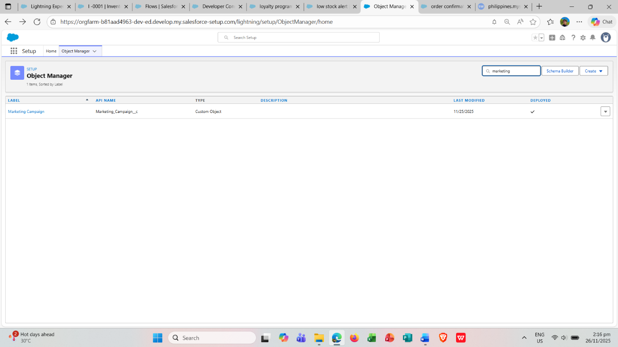

**Data Management – Tabs**

Tabs were created for each custom object:

* Tab - HandsMen Customer
* Tab - HandsMen Product
* Tab - HandsMen Order
* Tab - Inventory
* Tab - Marketing Campaign

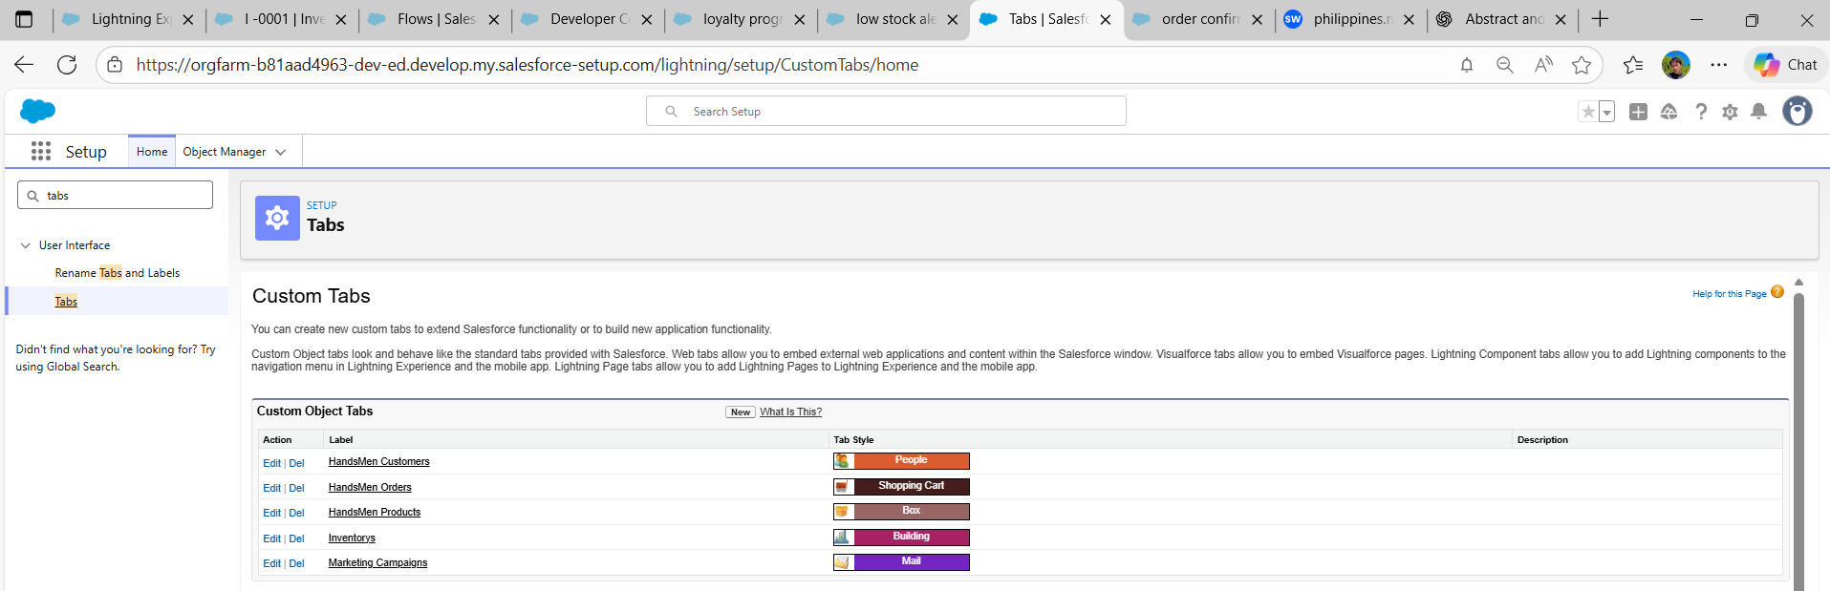

**Data Management – App Manager**

* A new Lightning App named HandsMen Threads was created from the App Manager.

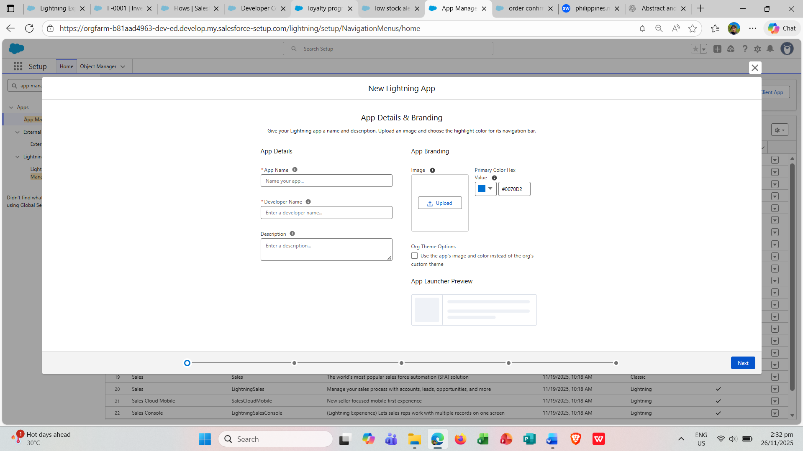

**Data Management- Fields**

* Fields and lookup relationships were created for all five custom objects: HandsMen Customer, HandsMen Product, HandsMen Order, Inventory, and Marketing Campaign.

**HandsMen Customer**

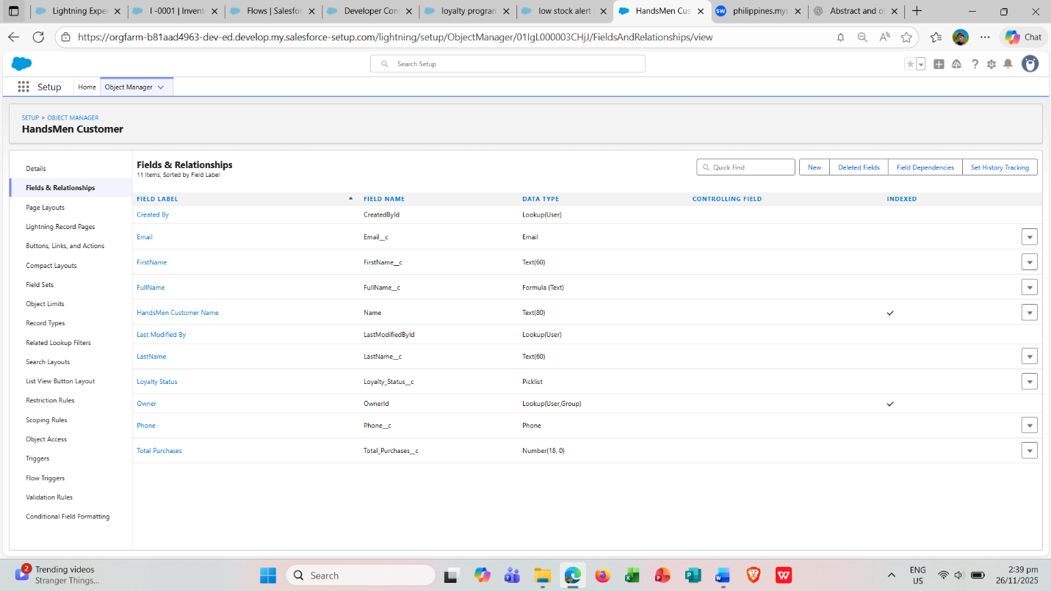

**HandsMen Product**

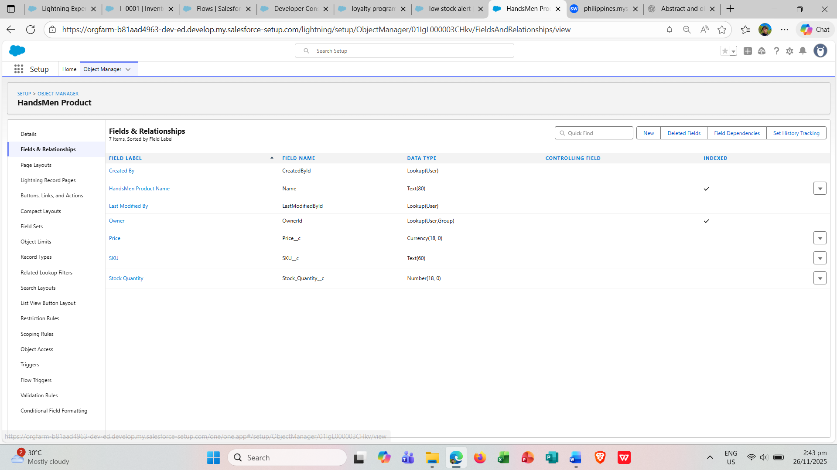

**HandsMen Order**

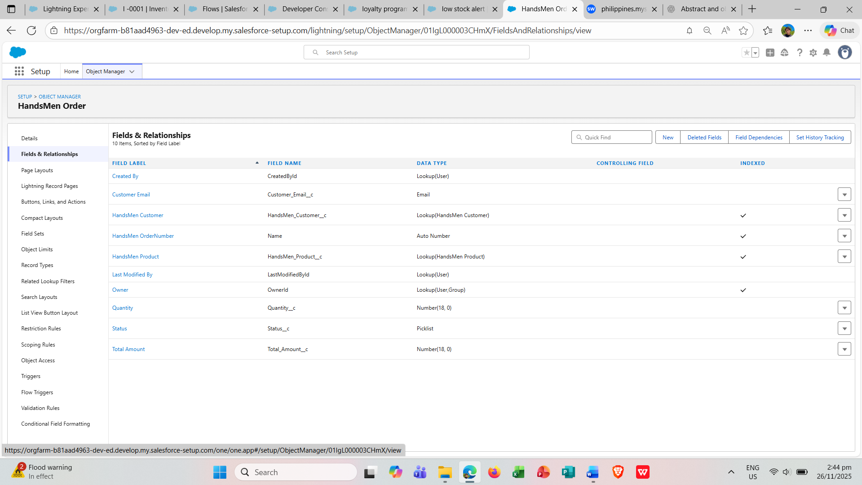

**Inventory**

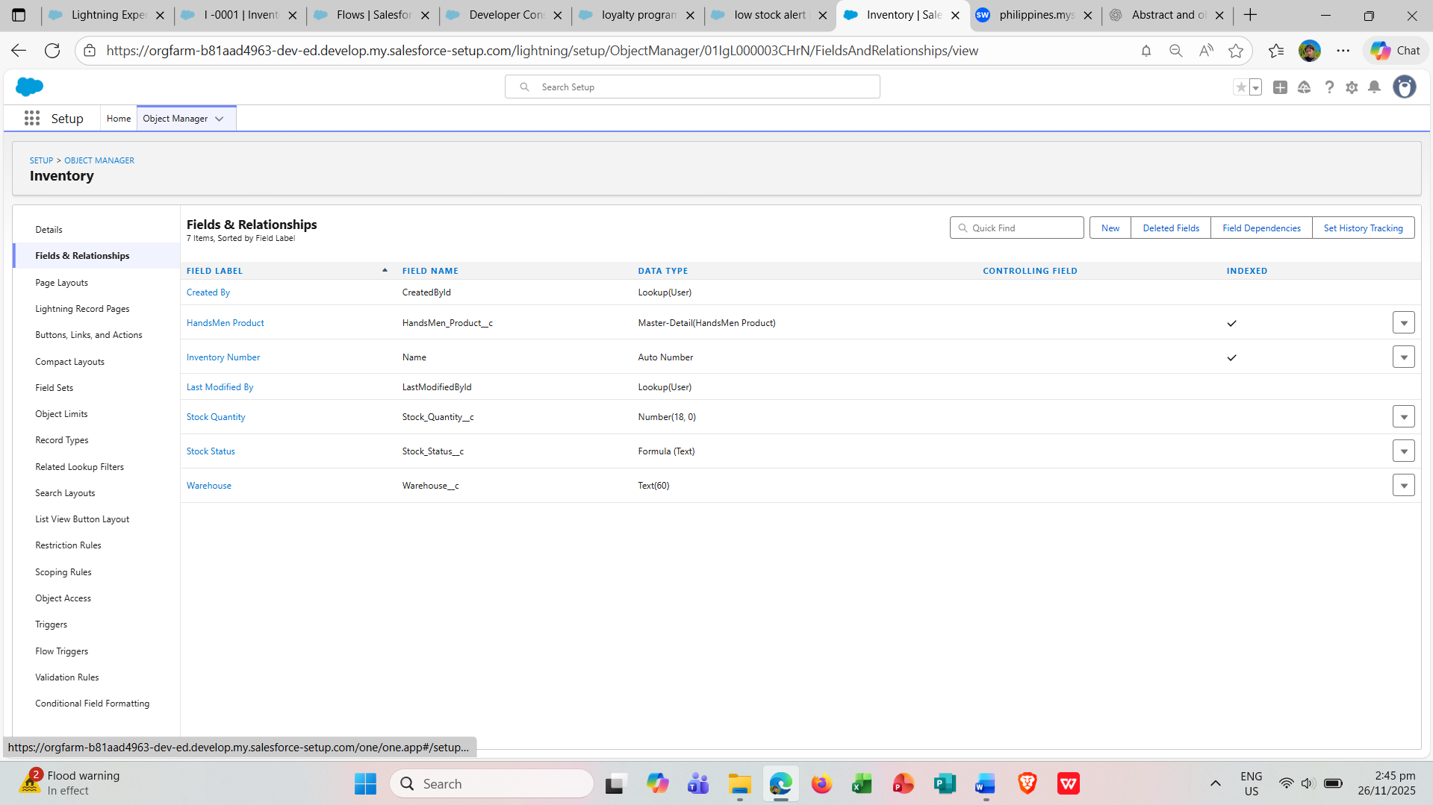

**Marketing Campaign**

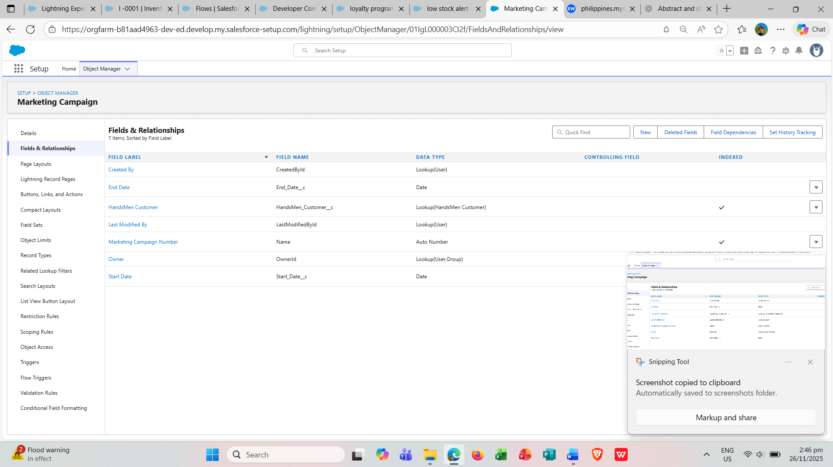

**Data Configuration:**

* Validation rules were created for HandsMen Order, Inventory, and HandsMen Customer.

**HandsMen Customer**

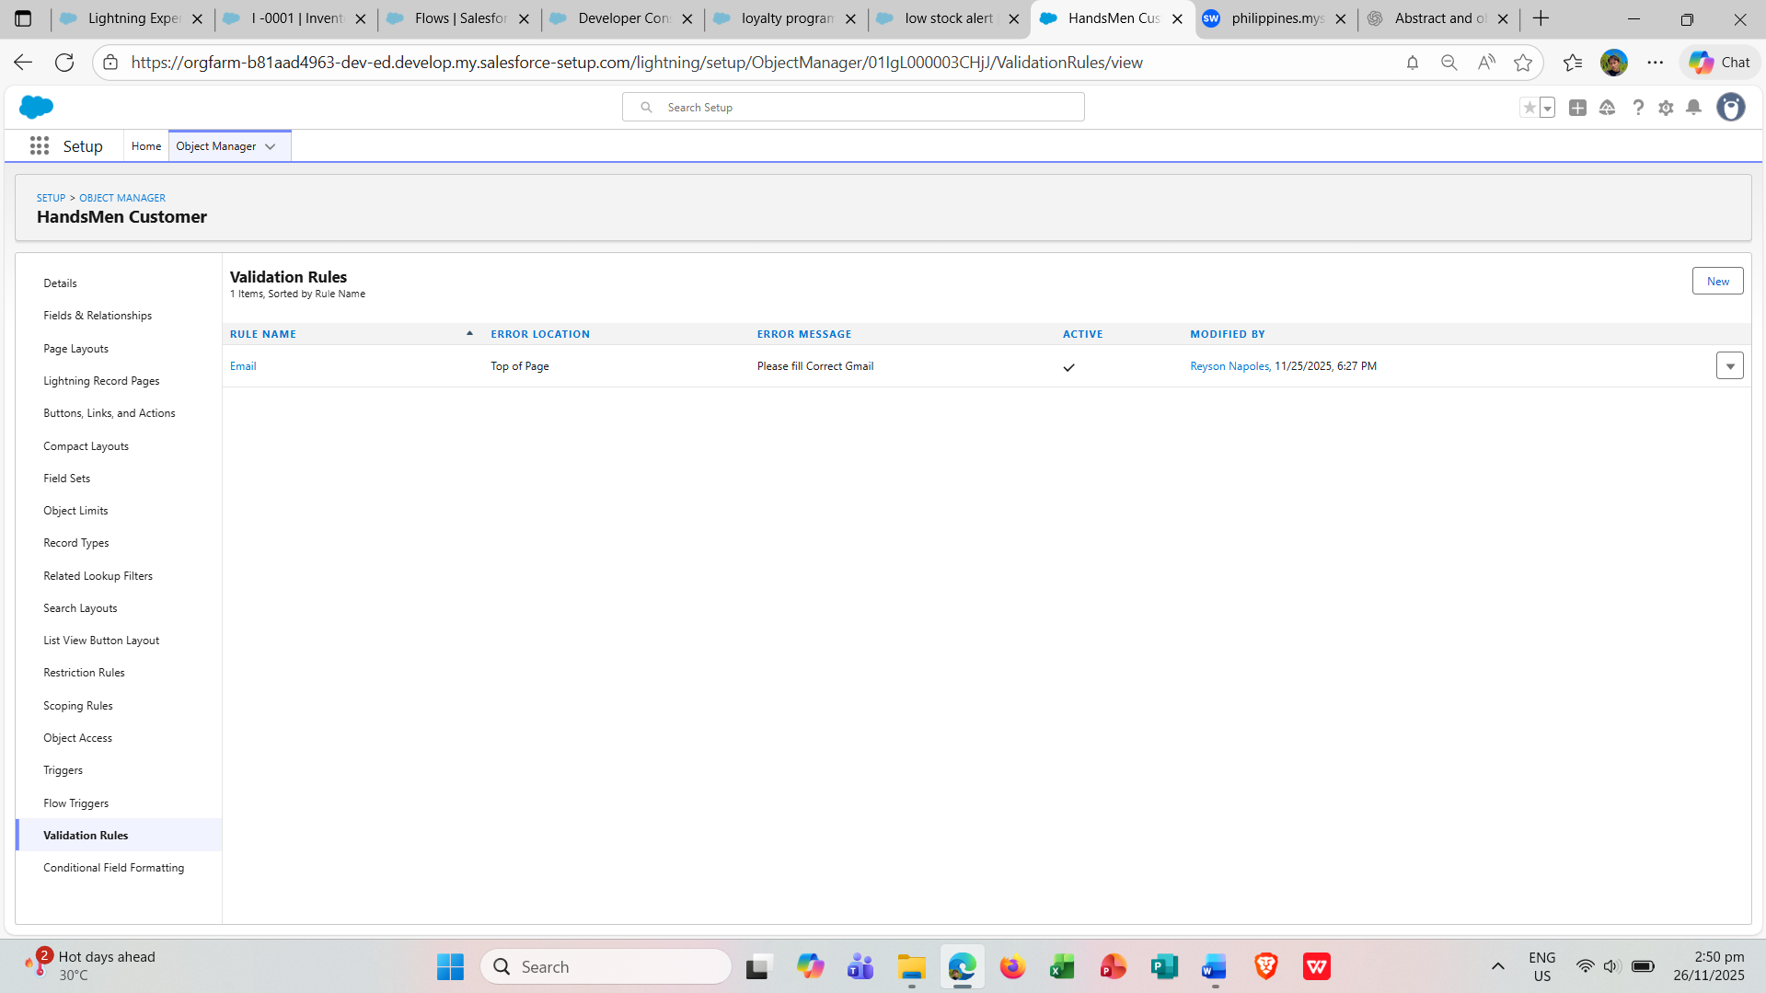

**HandsMen Order**

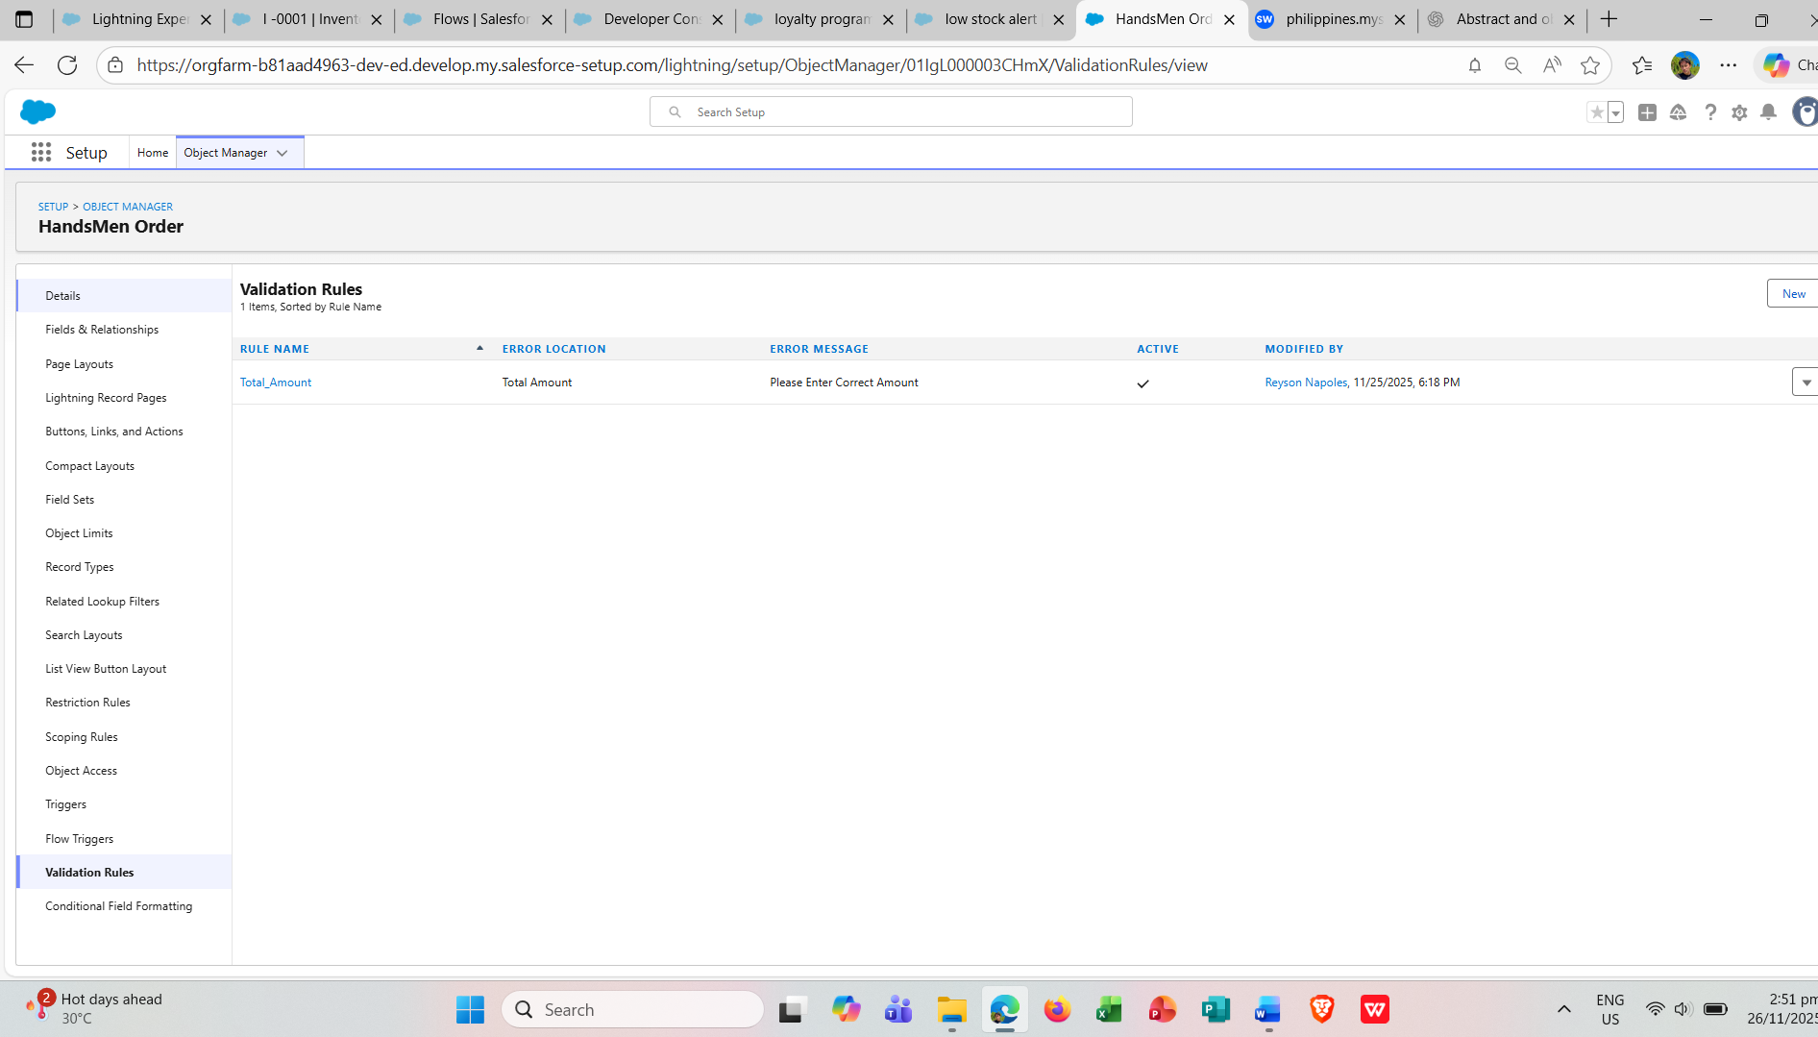

**Inventory**

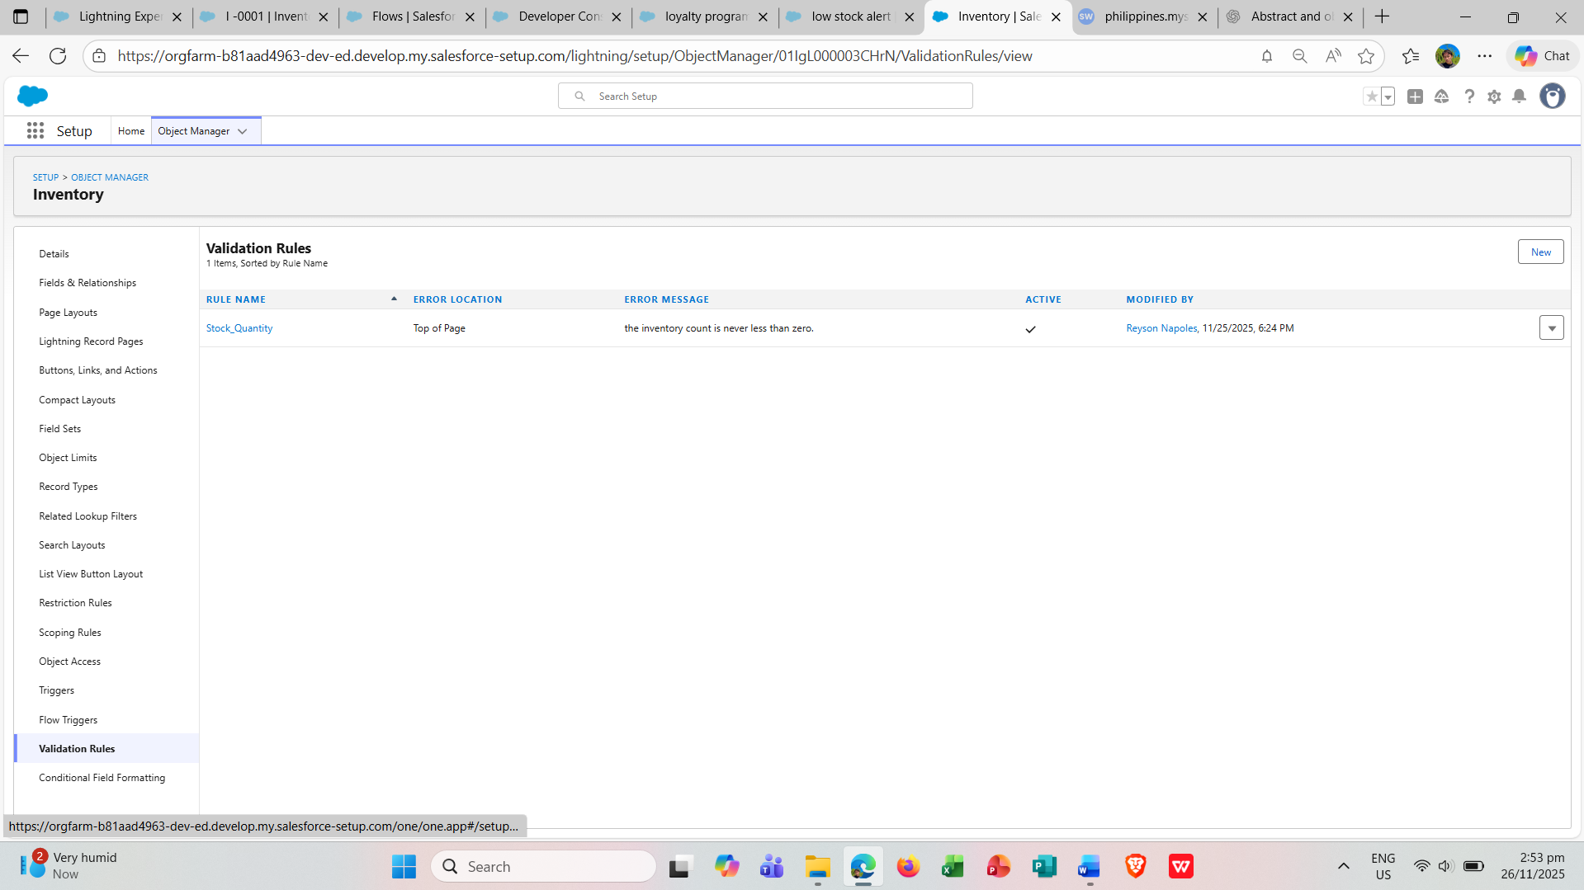

**Phase 2: Development**

**Data Security**

* Profiles: Inventory, Marketing, and Sales profiles were created under the CEO profile.
* Users: Multiple users named Niklaus Mikaelson, Kol Mikaelson, and Daniel Mikaelson were created with different roles but the same profile.

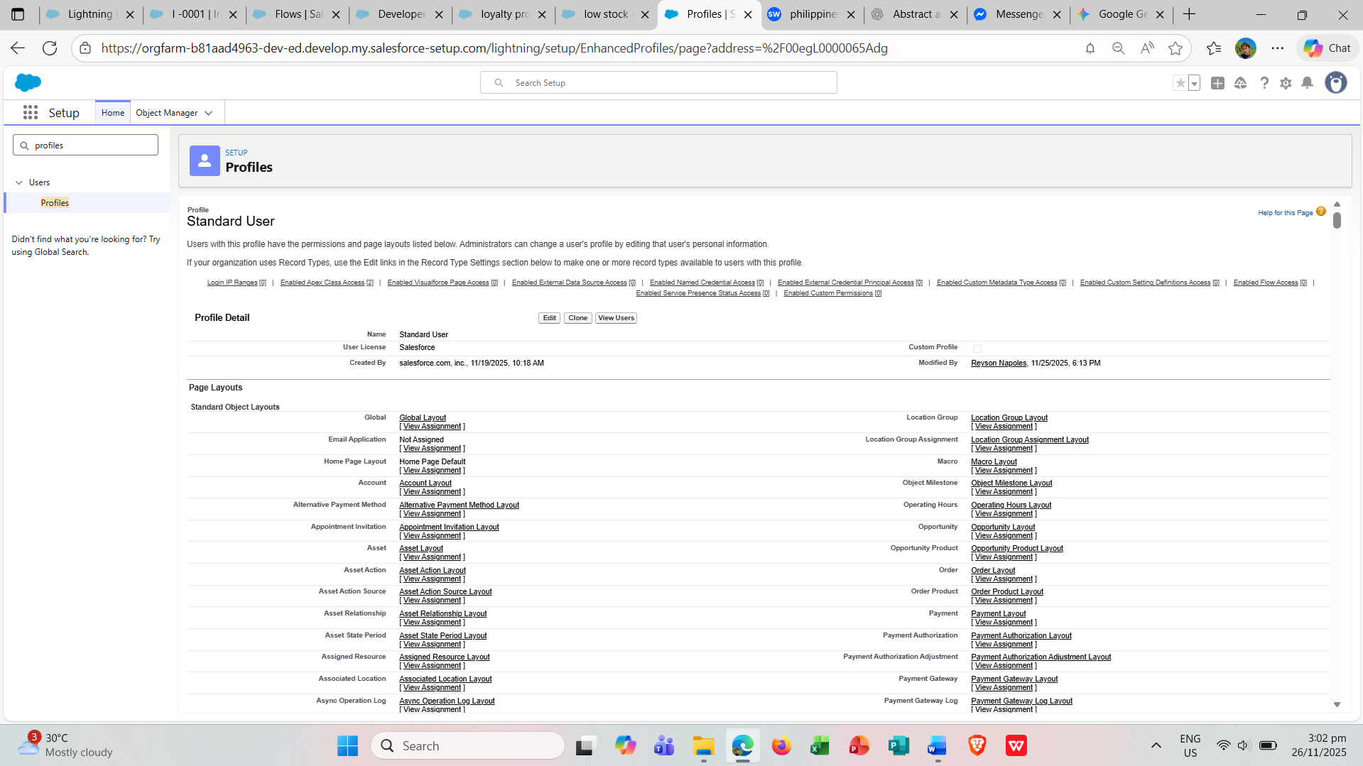

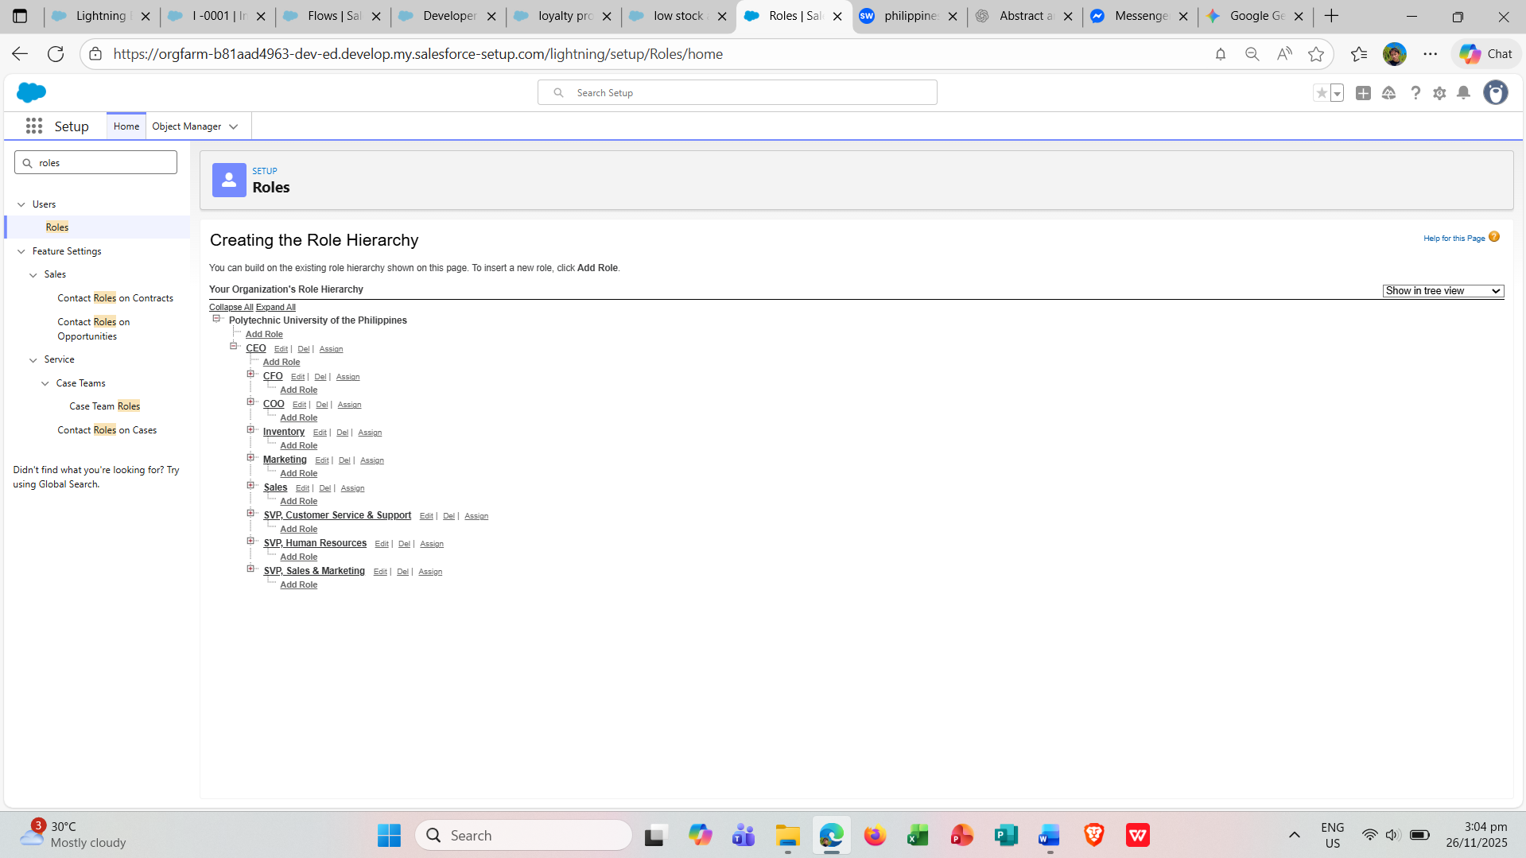

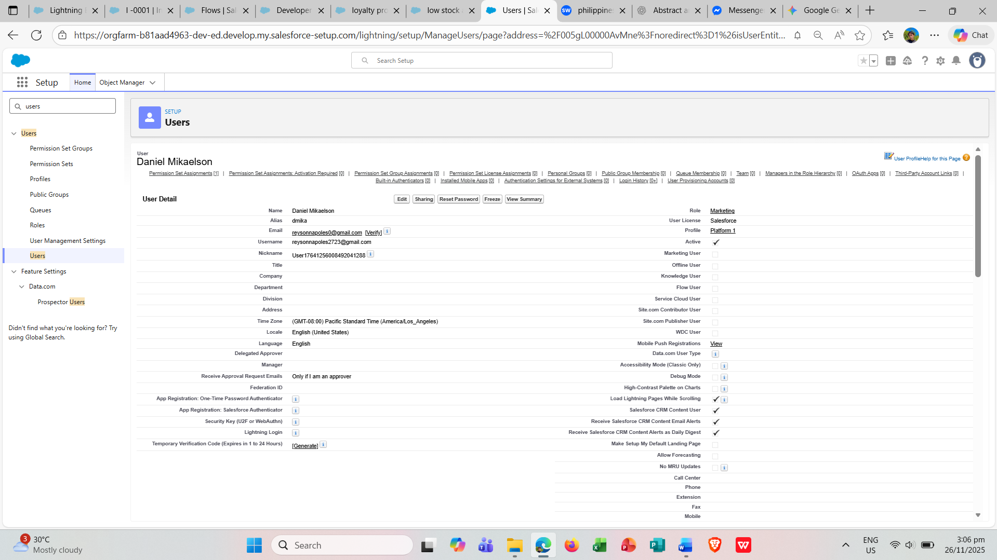

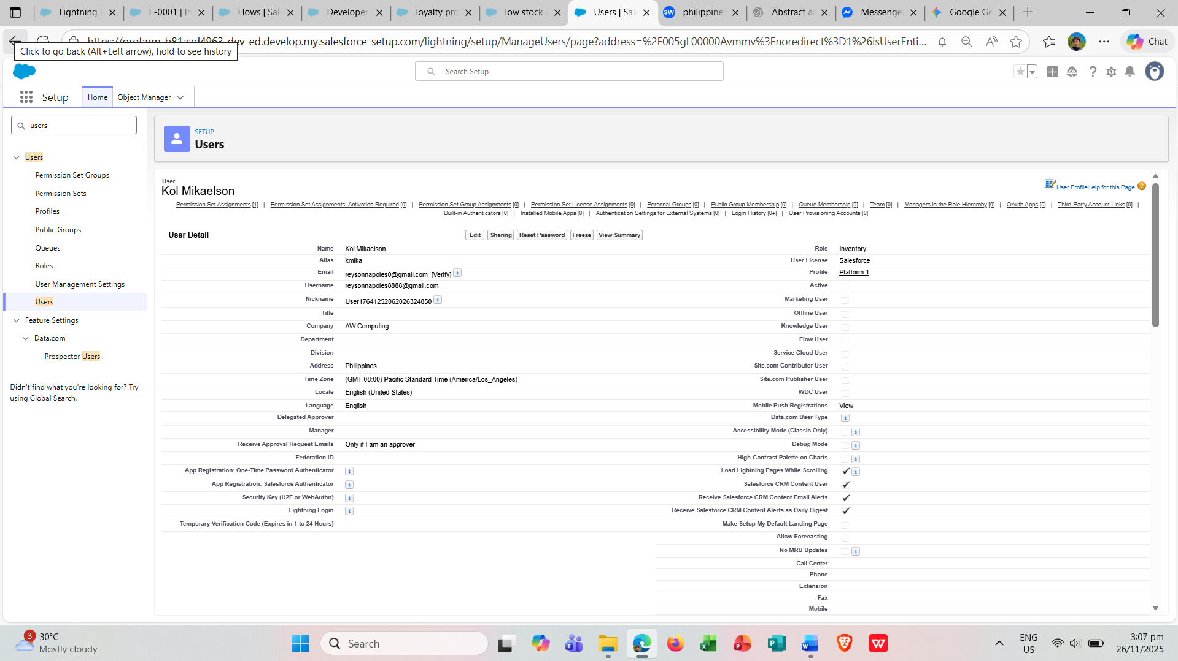

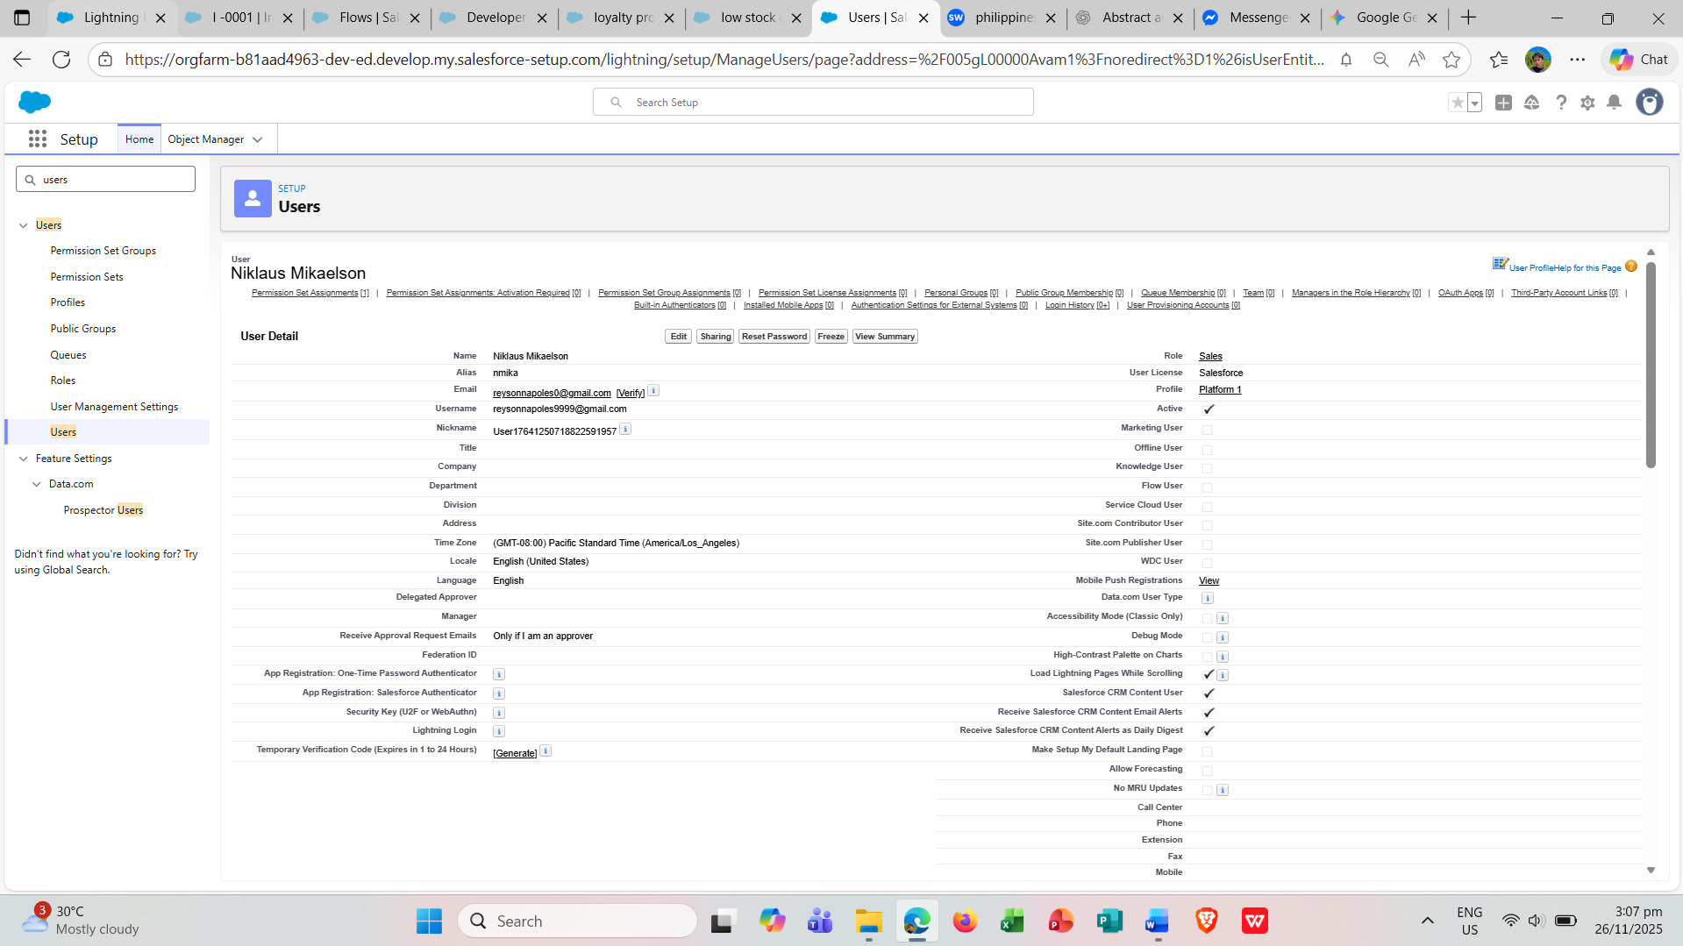

**Permission Sets:**

* Sales Permission Set: Created with Read, Create, Edit, and Delete permissions for the HandsMen Customer and HandsMen Order objects, and assigned to Niklaus Mikaelson.
* Inventory Permission Set: Created with Read and Edit permissions for HandsMen Products and Inventory, and assigned to Niklaus Mikaelson.
* Marketing Permission Set: Created with Read permissions for Marketing Campaigns and HandsMen Customers, and assigned to Ajay Mikaelson**.**

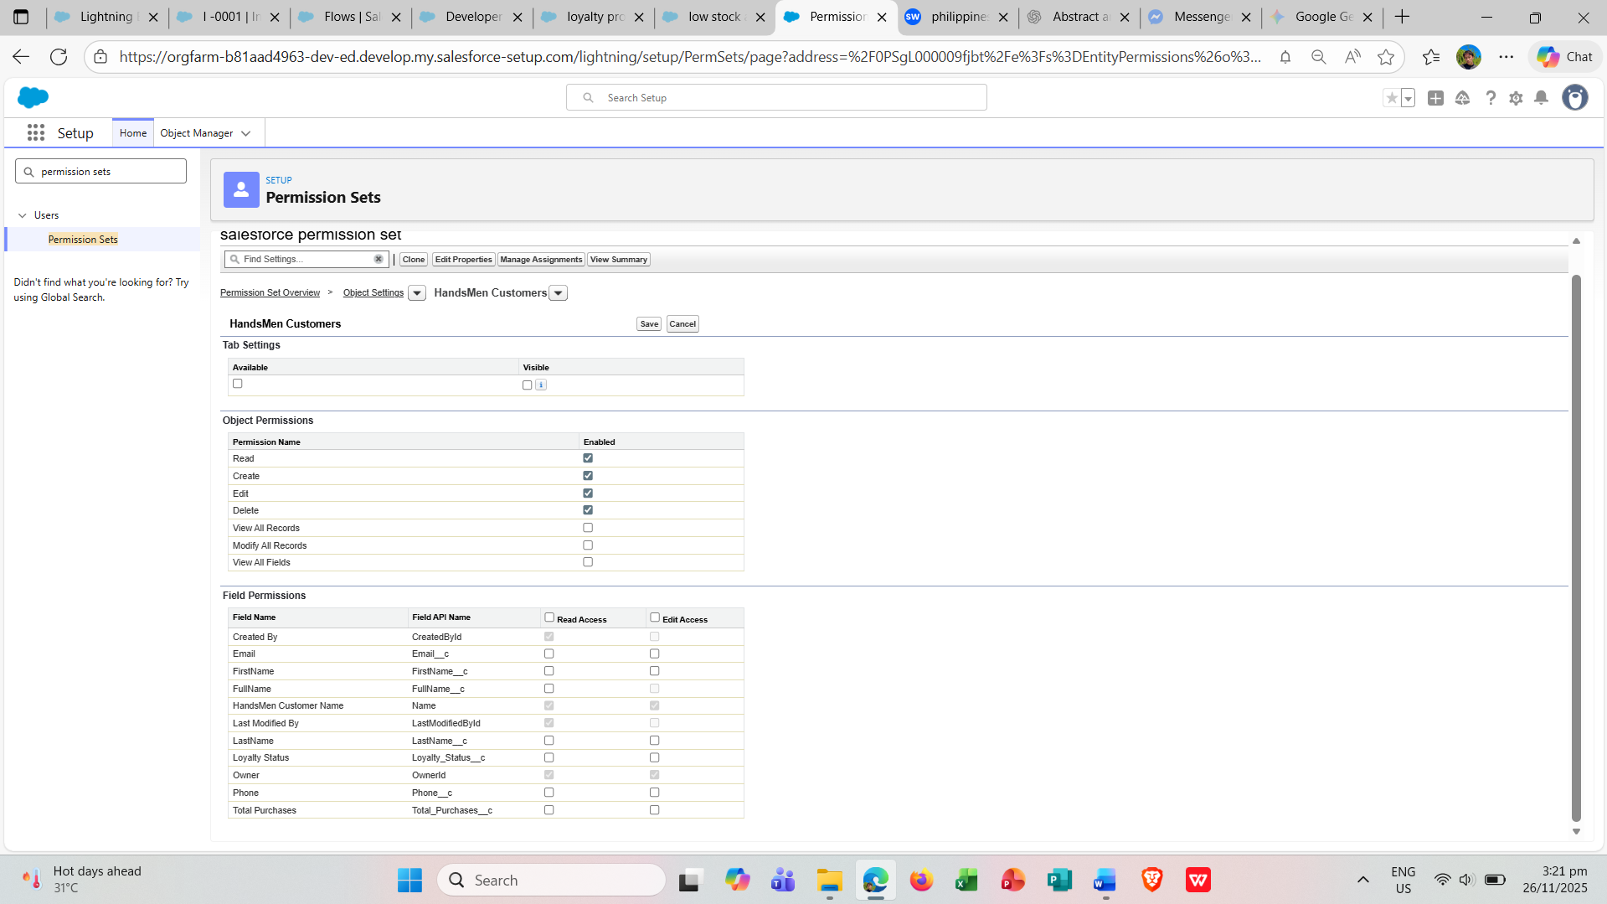

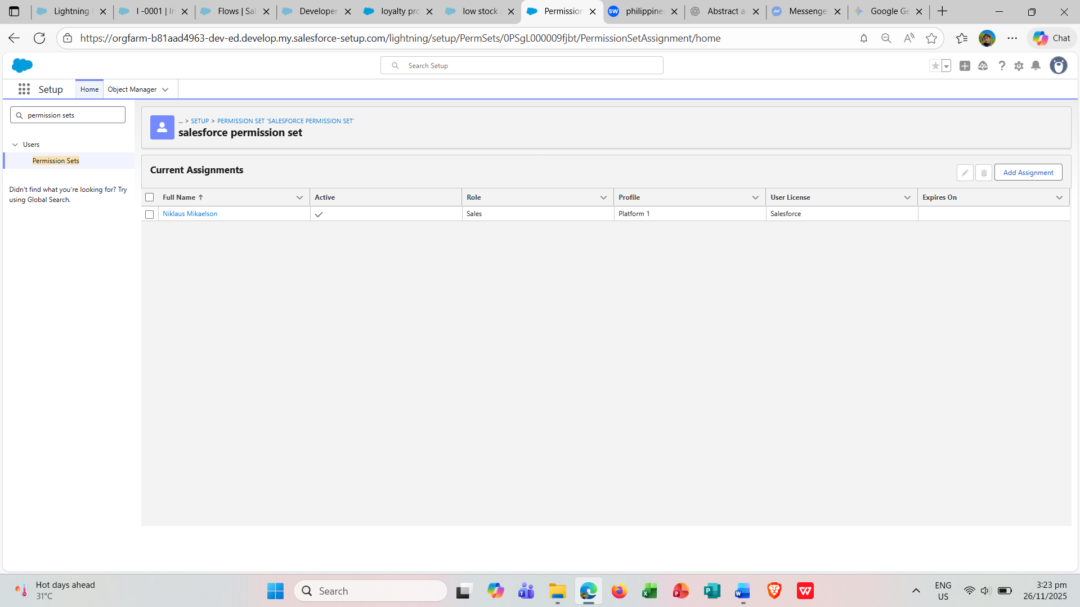

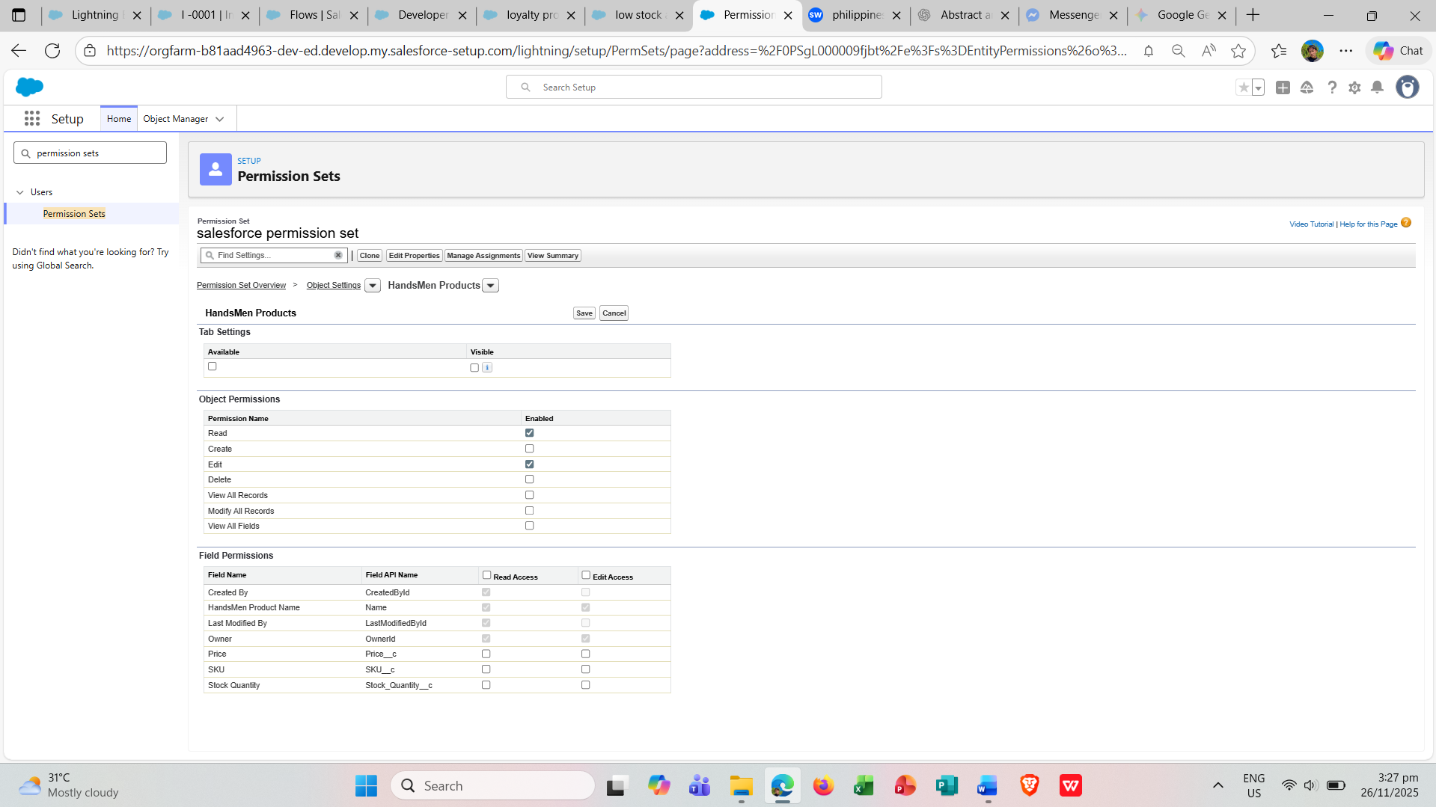

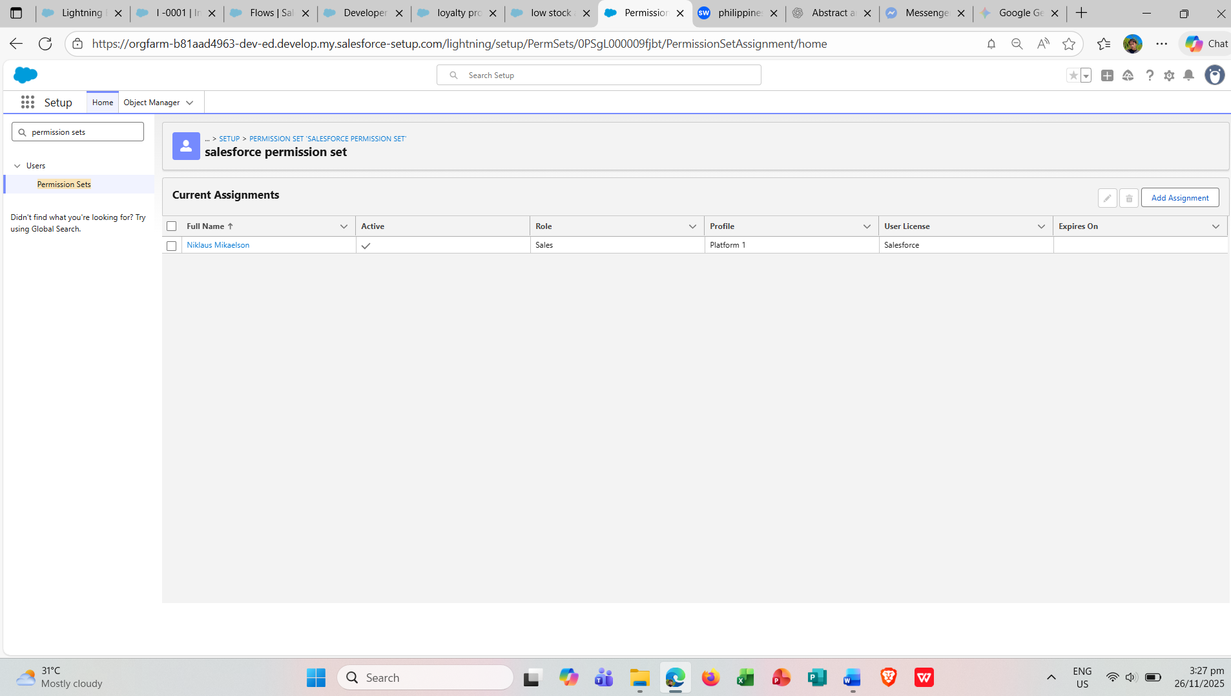

**Email Template**

**Classic Email Templates were created with the following labels:**

* Order_Confirmation_Email
* Low Stock Alert
* Loyalty Program Email

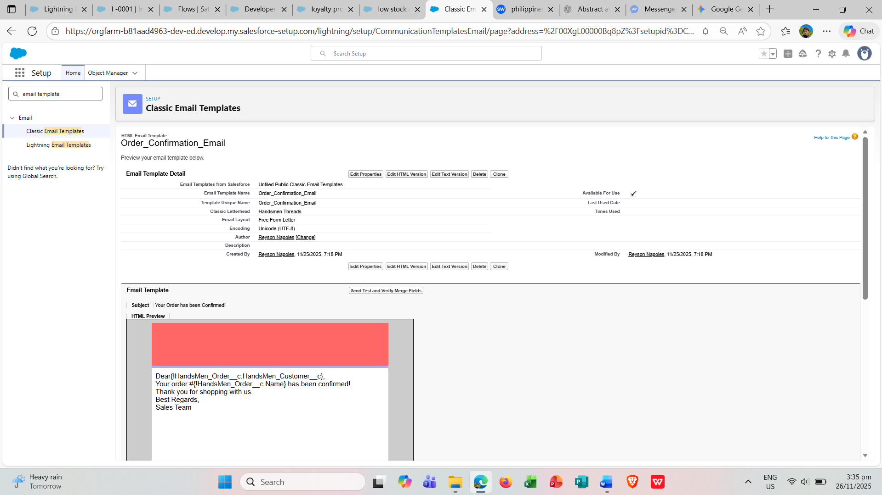

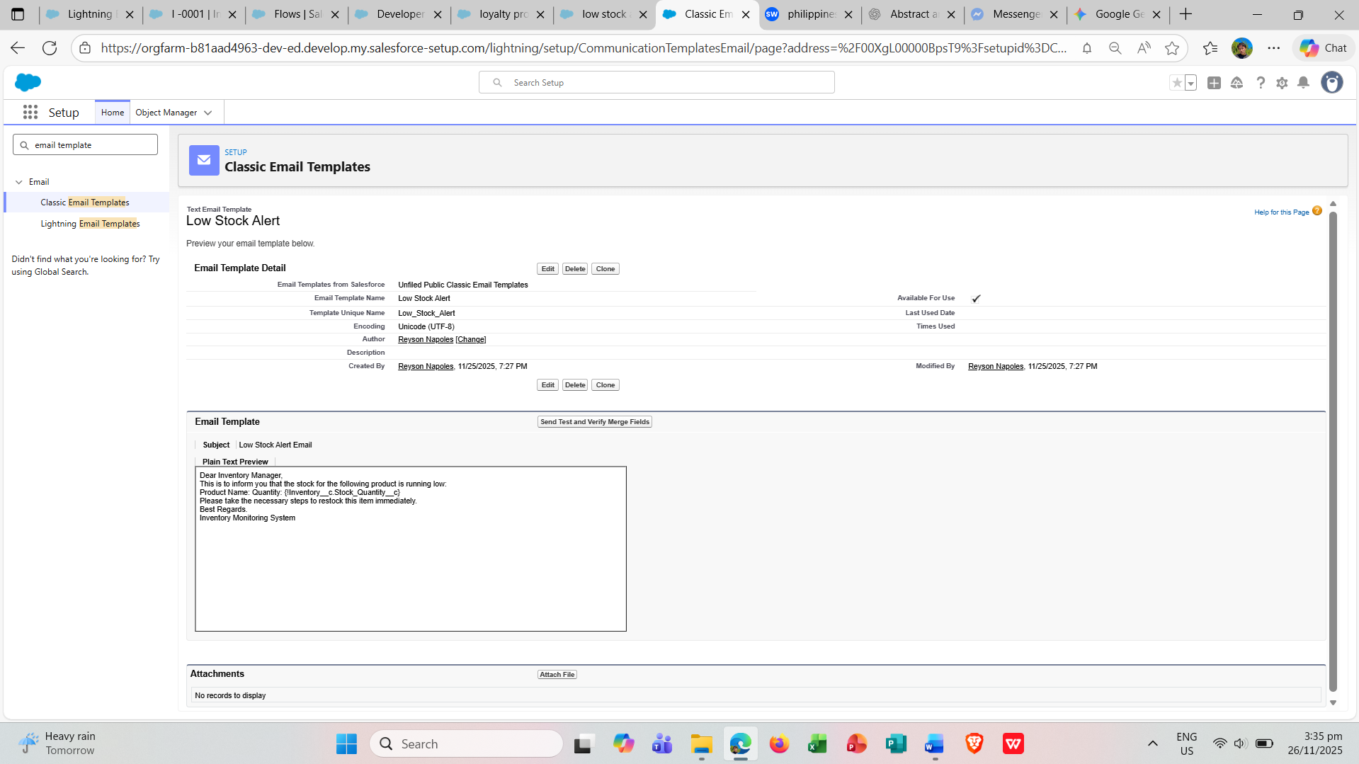

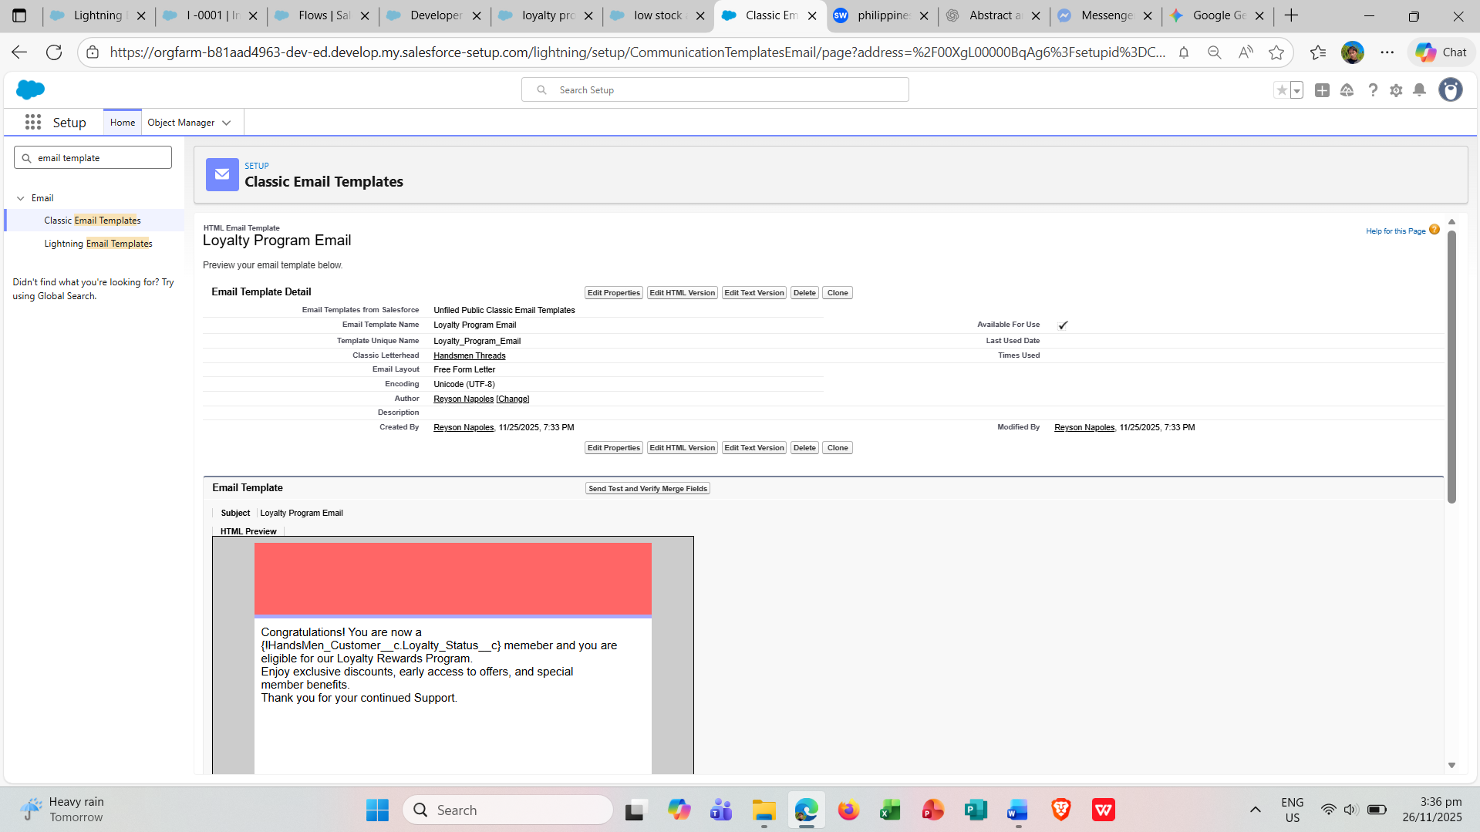

**An Email Alert was also created.**

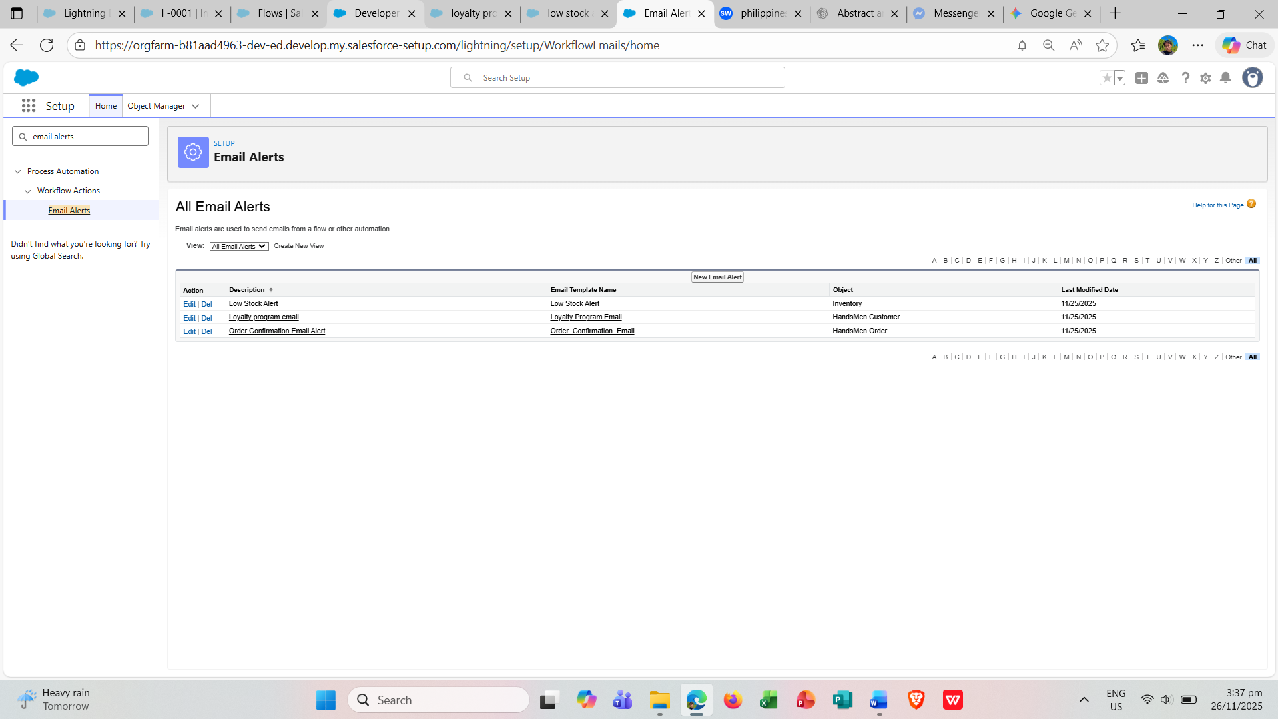

**Flows**

Record-Triggered Flows were created for the following automations:

* Order Confirmation Flow
* Low Stock Alert Flow
* Loyalty Status Flow

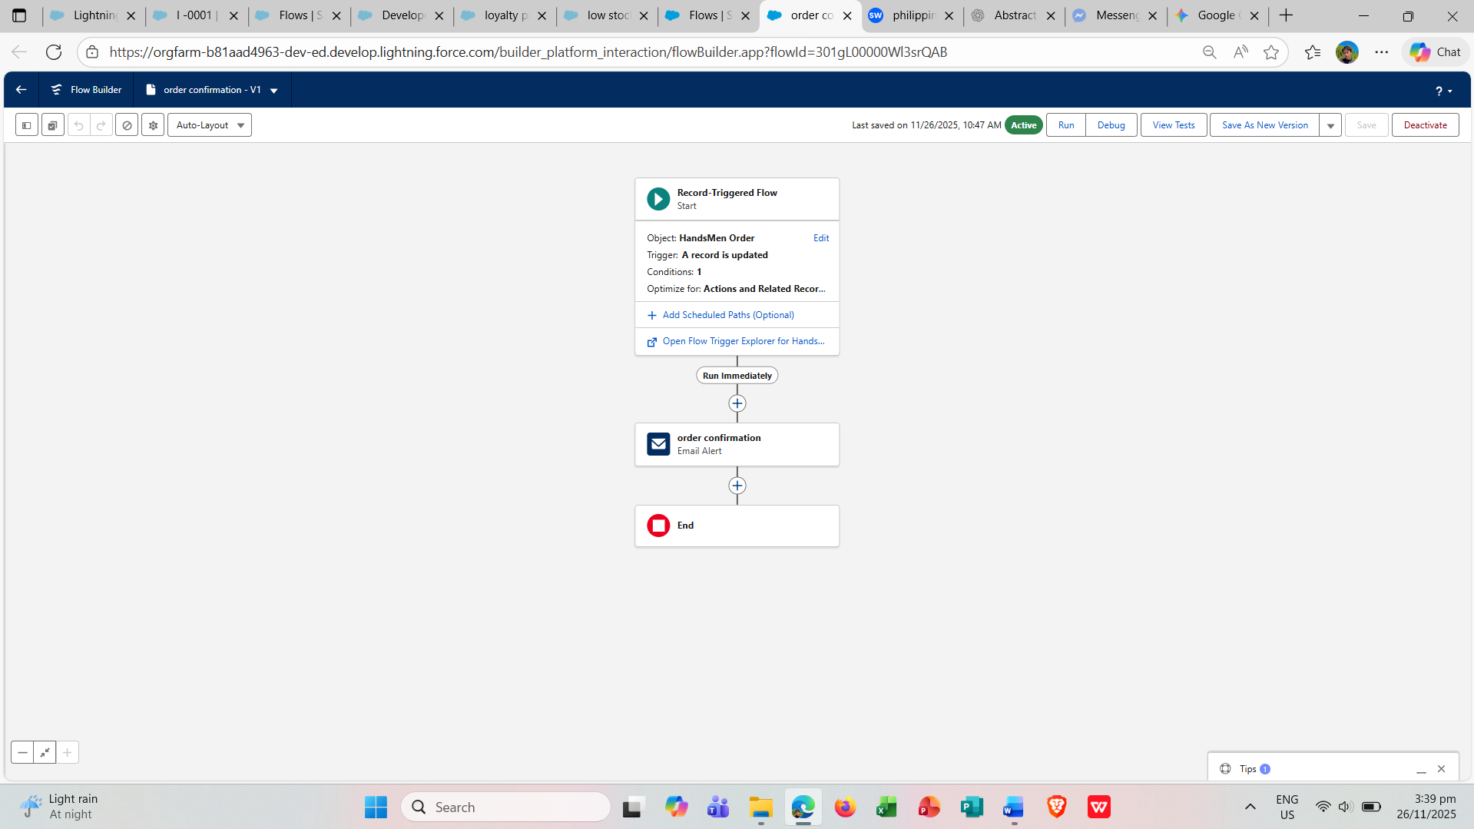

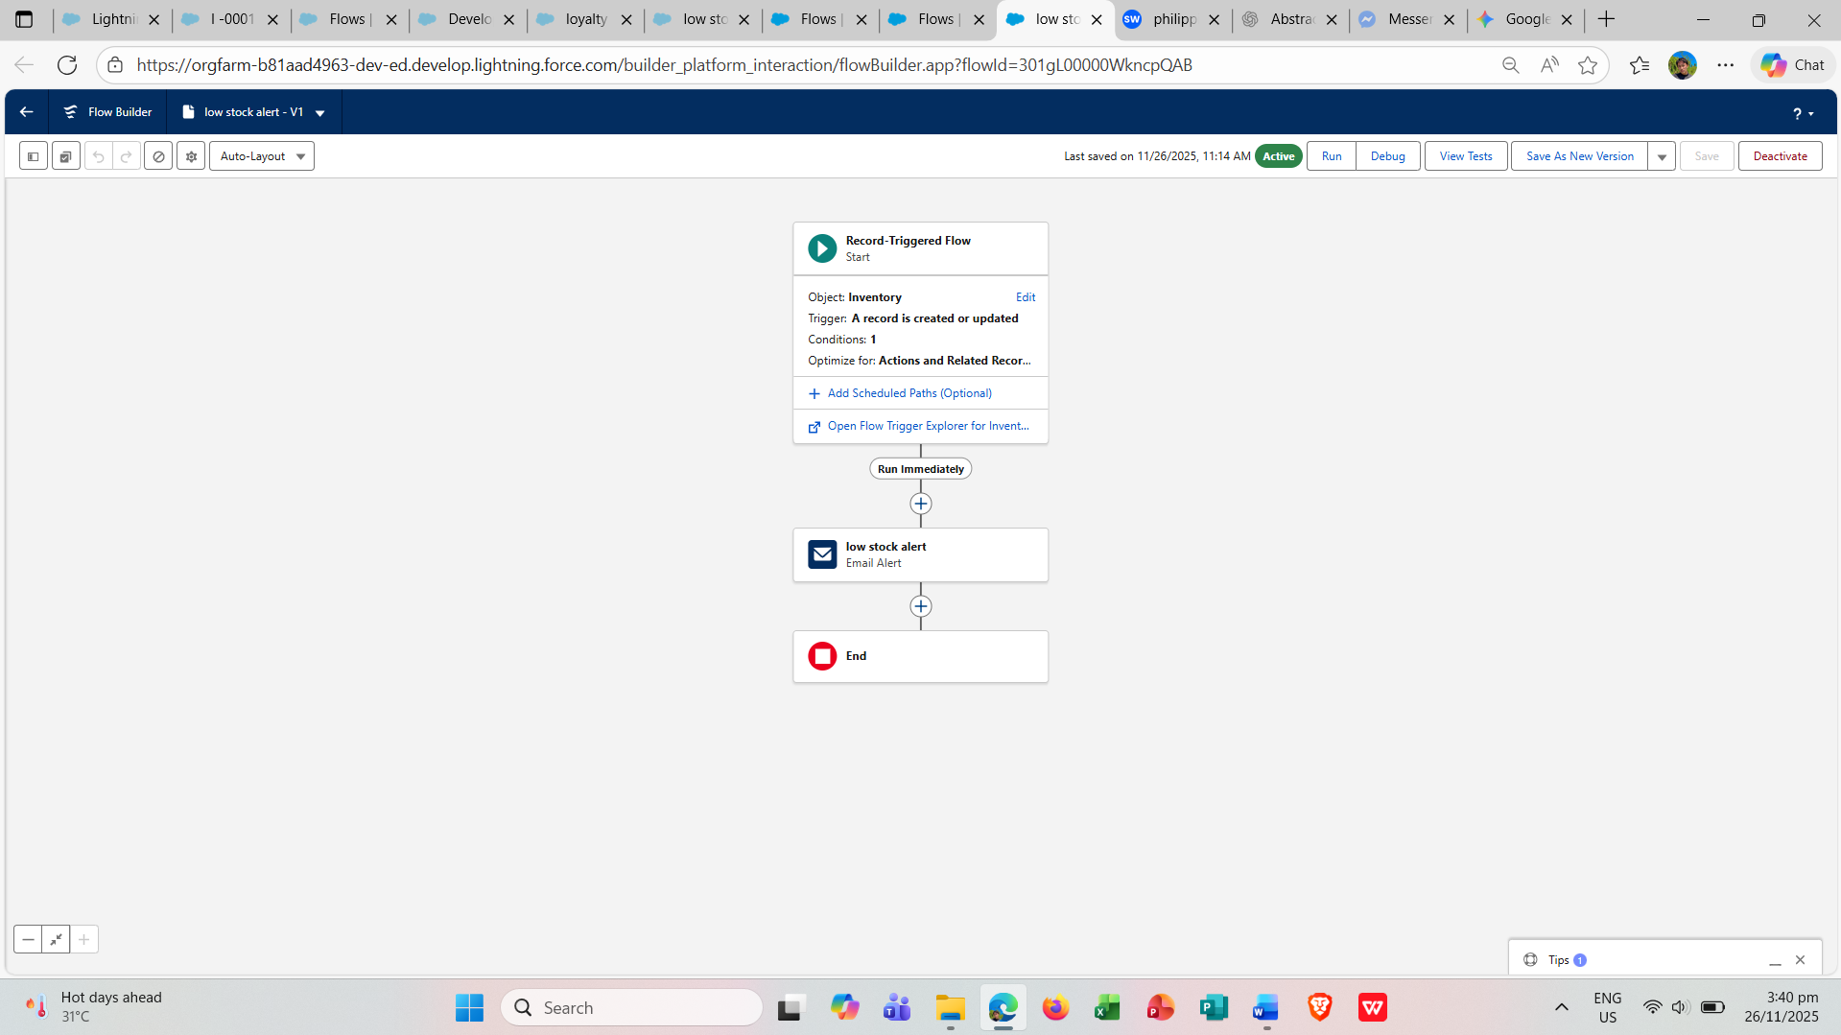

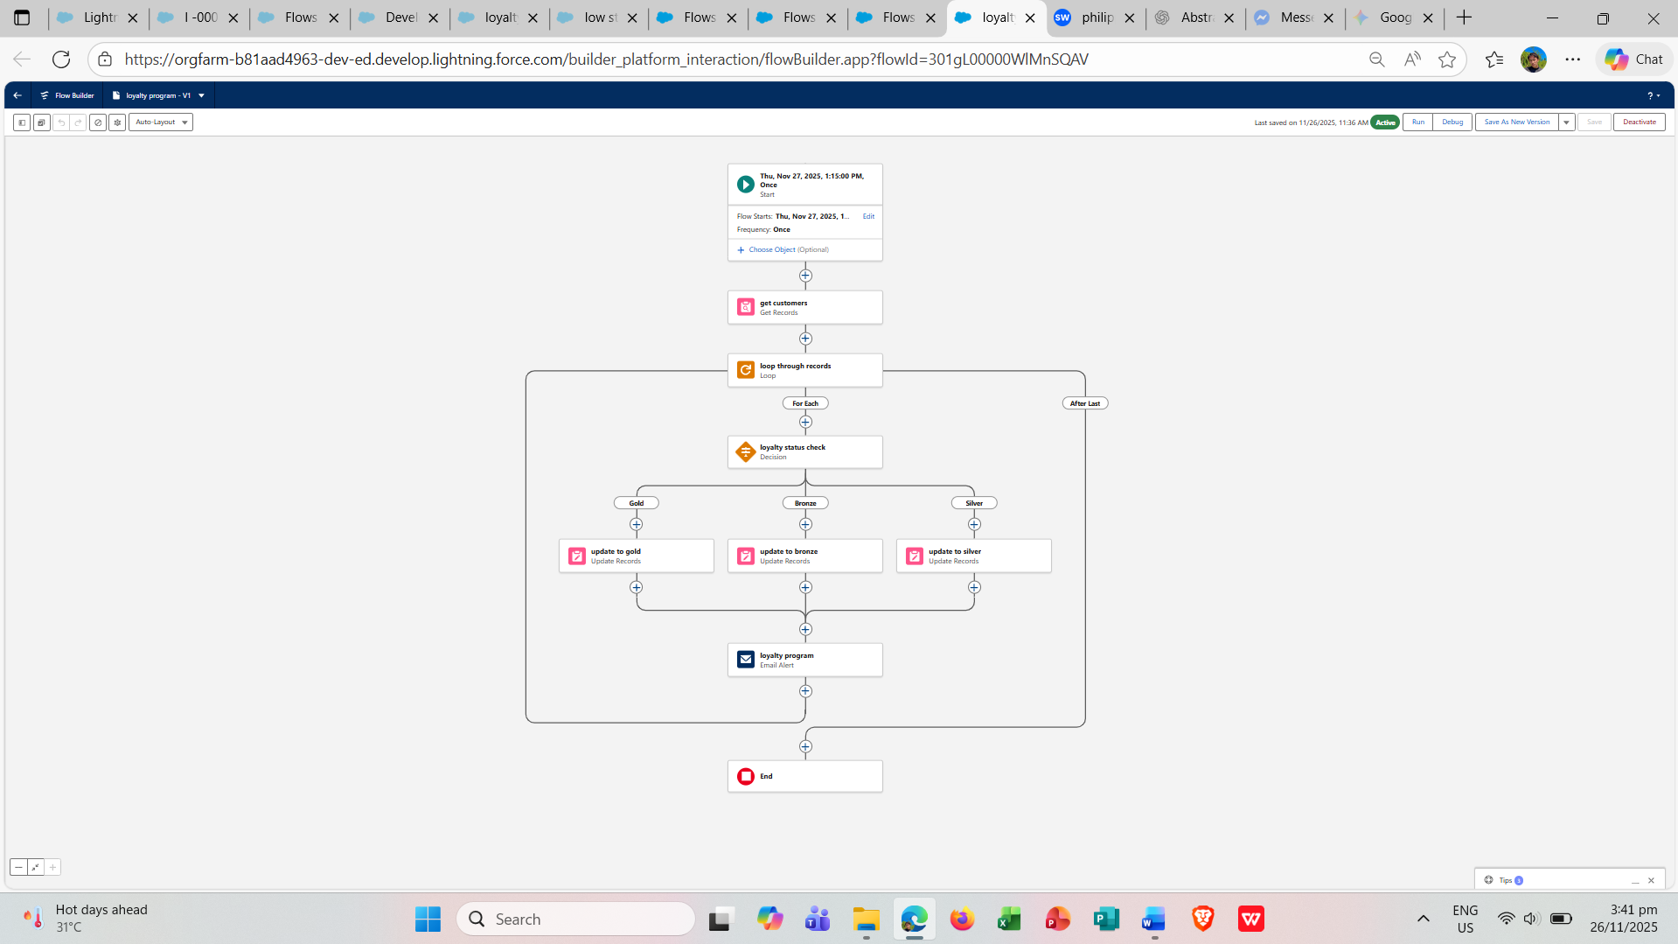

**Automation Using Apex**

* **Apex Triggers** were created with the following trigger names: Order Trigger, Stock Deduction, and Loyalty Status Update.
* An **Apex Class** was created named “OrderTriggerHandler”.
* A **Batch Apex** was created named “InventoryBatchJob”.

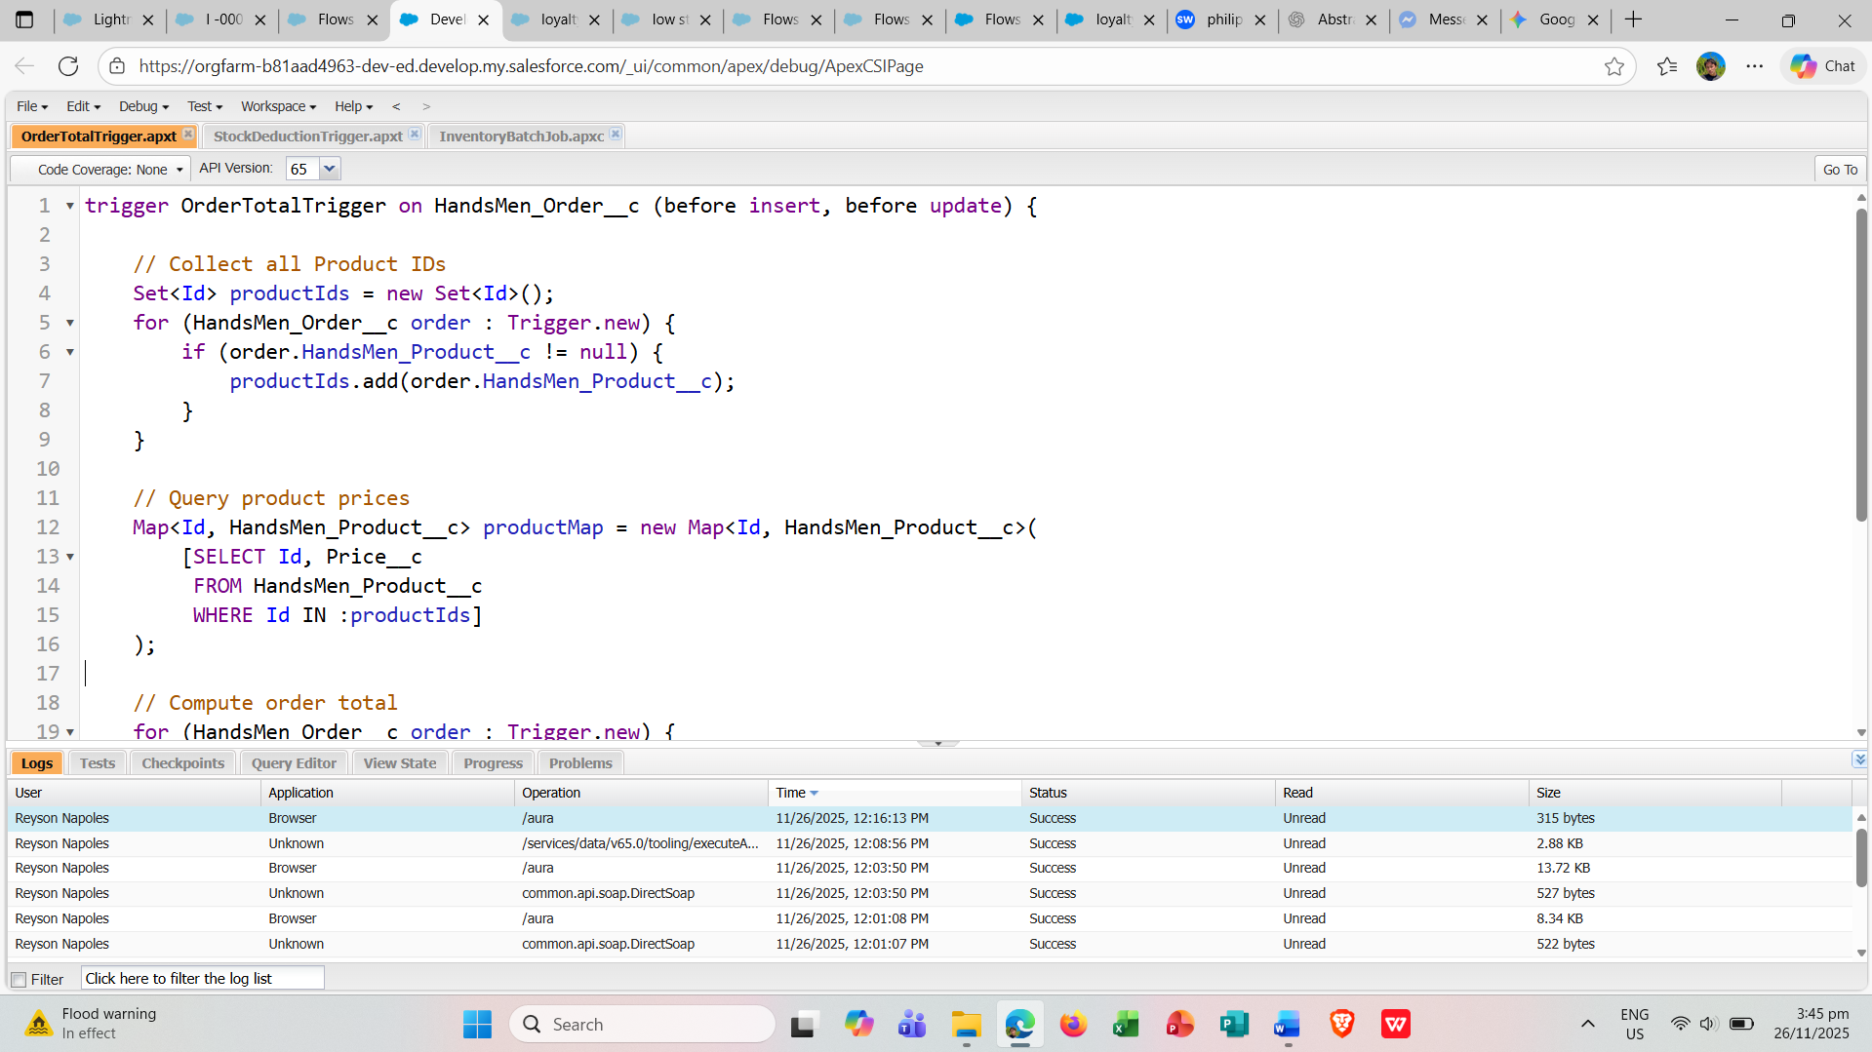

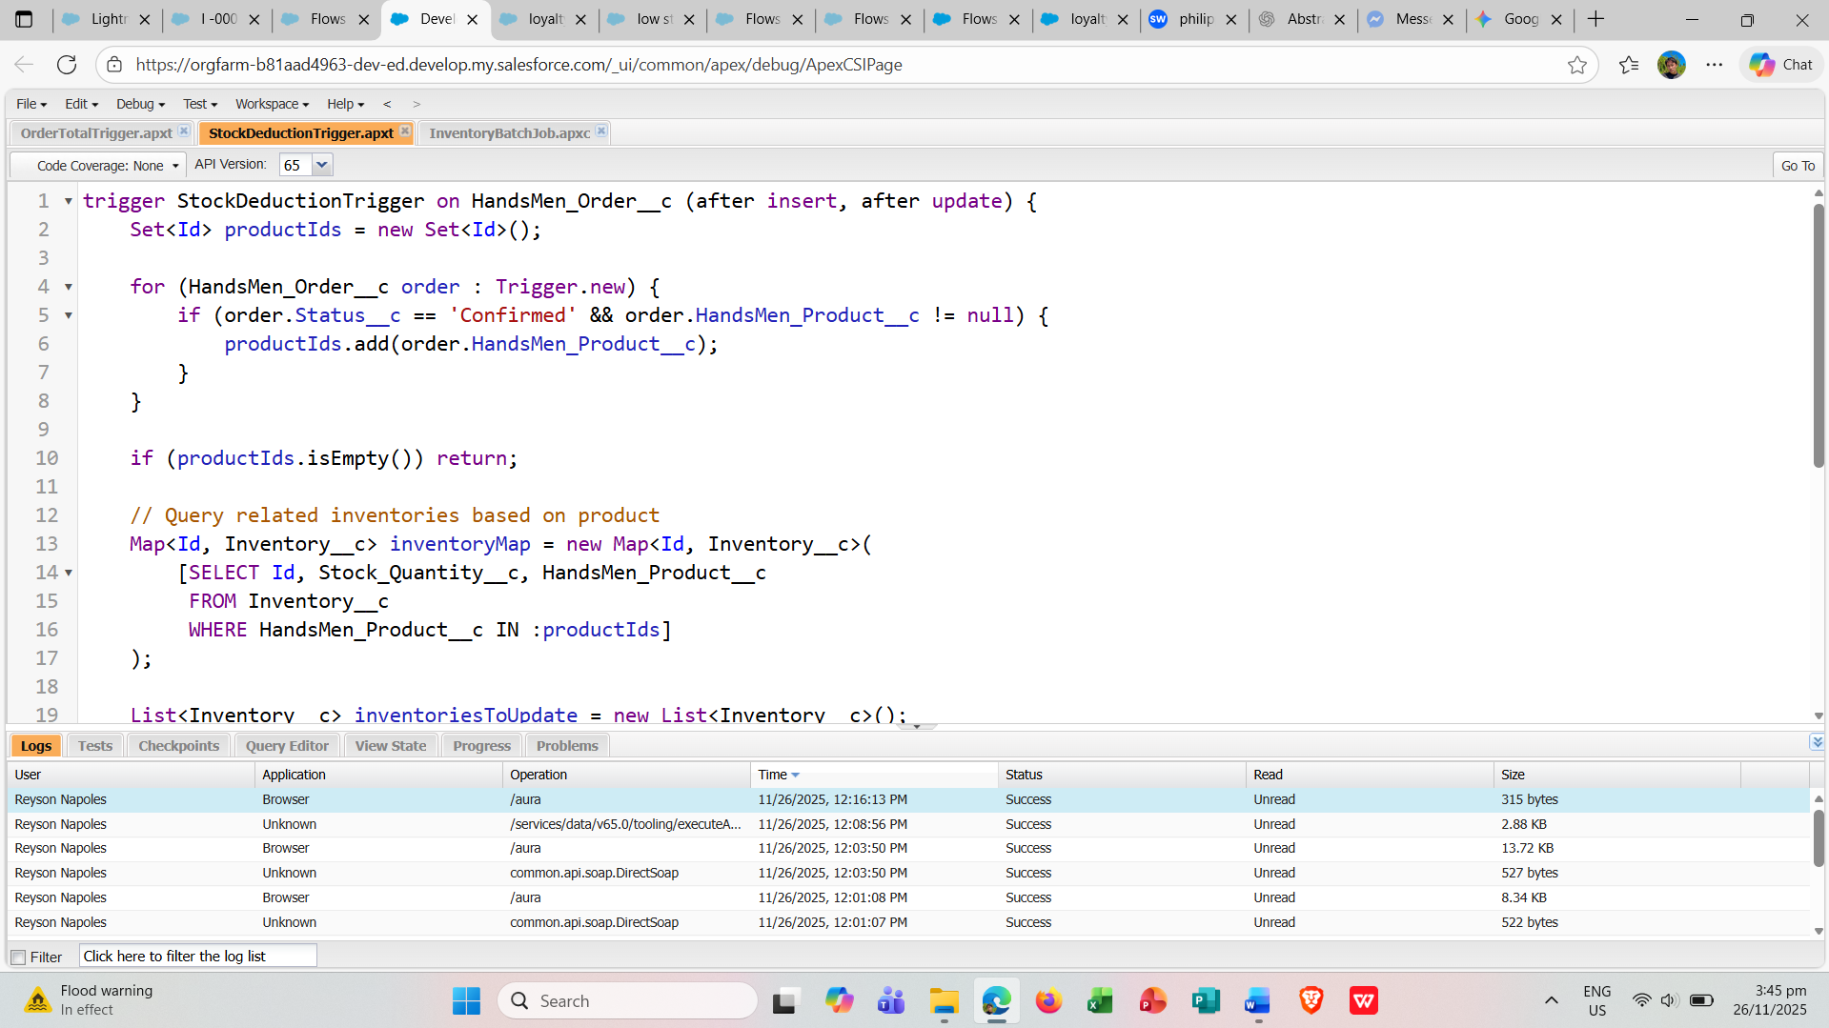

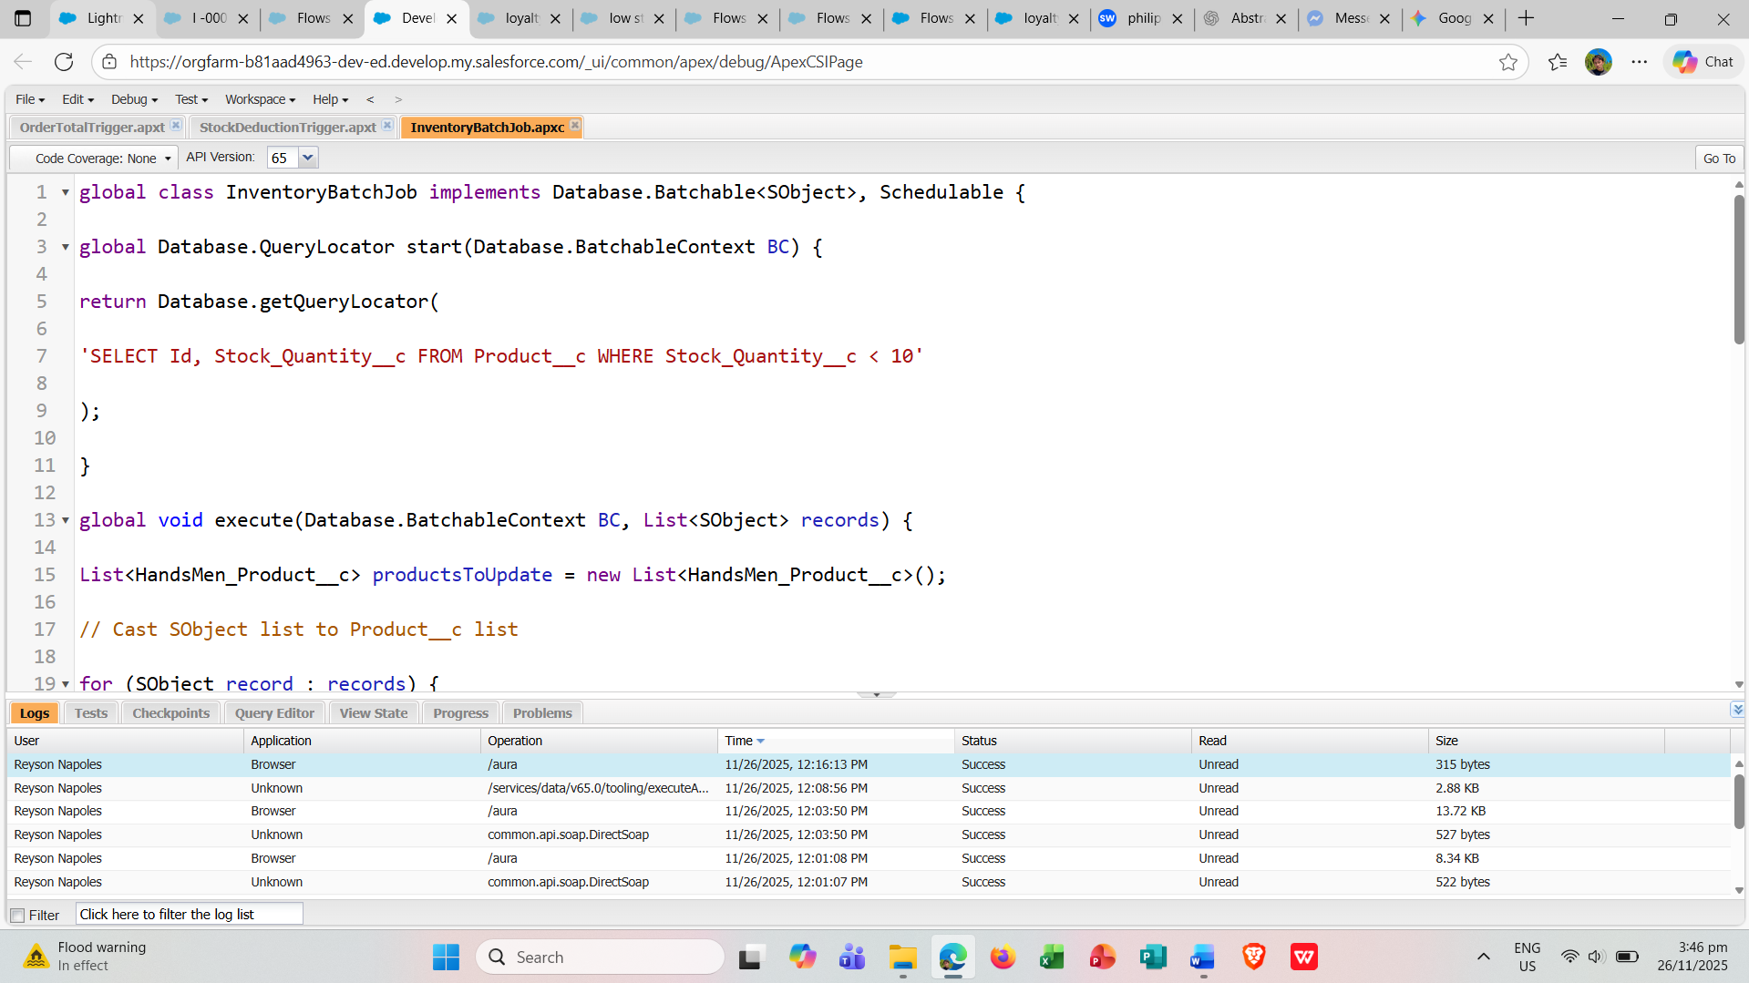

**Phase 3: Testing & QA**

* During this phase, all components of the Salesforce CRM system were thoroughly tested to verify their proper functionality. The primary objective was to detect and resolve any issues prior to deployment. Screenshots were taken throughout the testing process to document the outcomes.

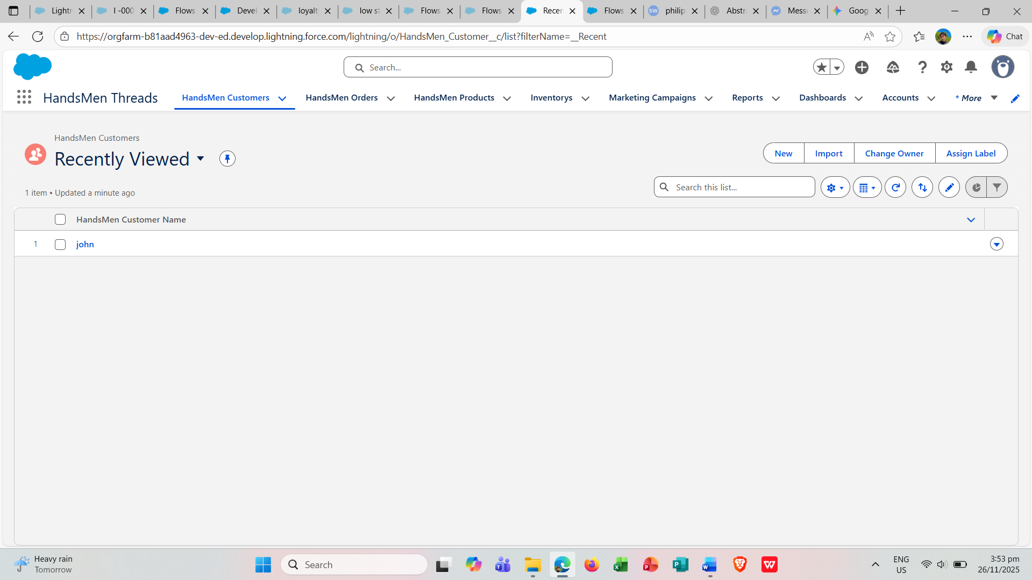

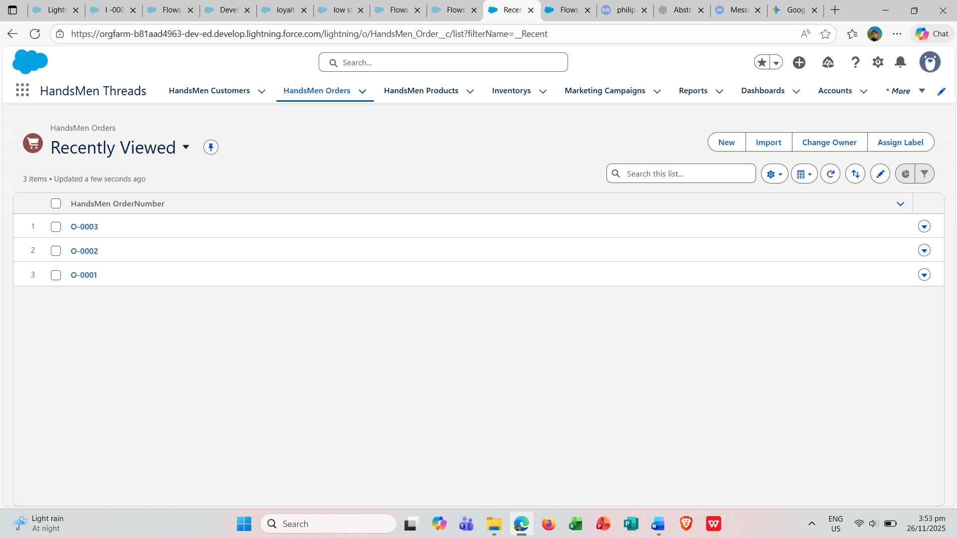

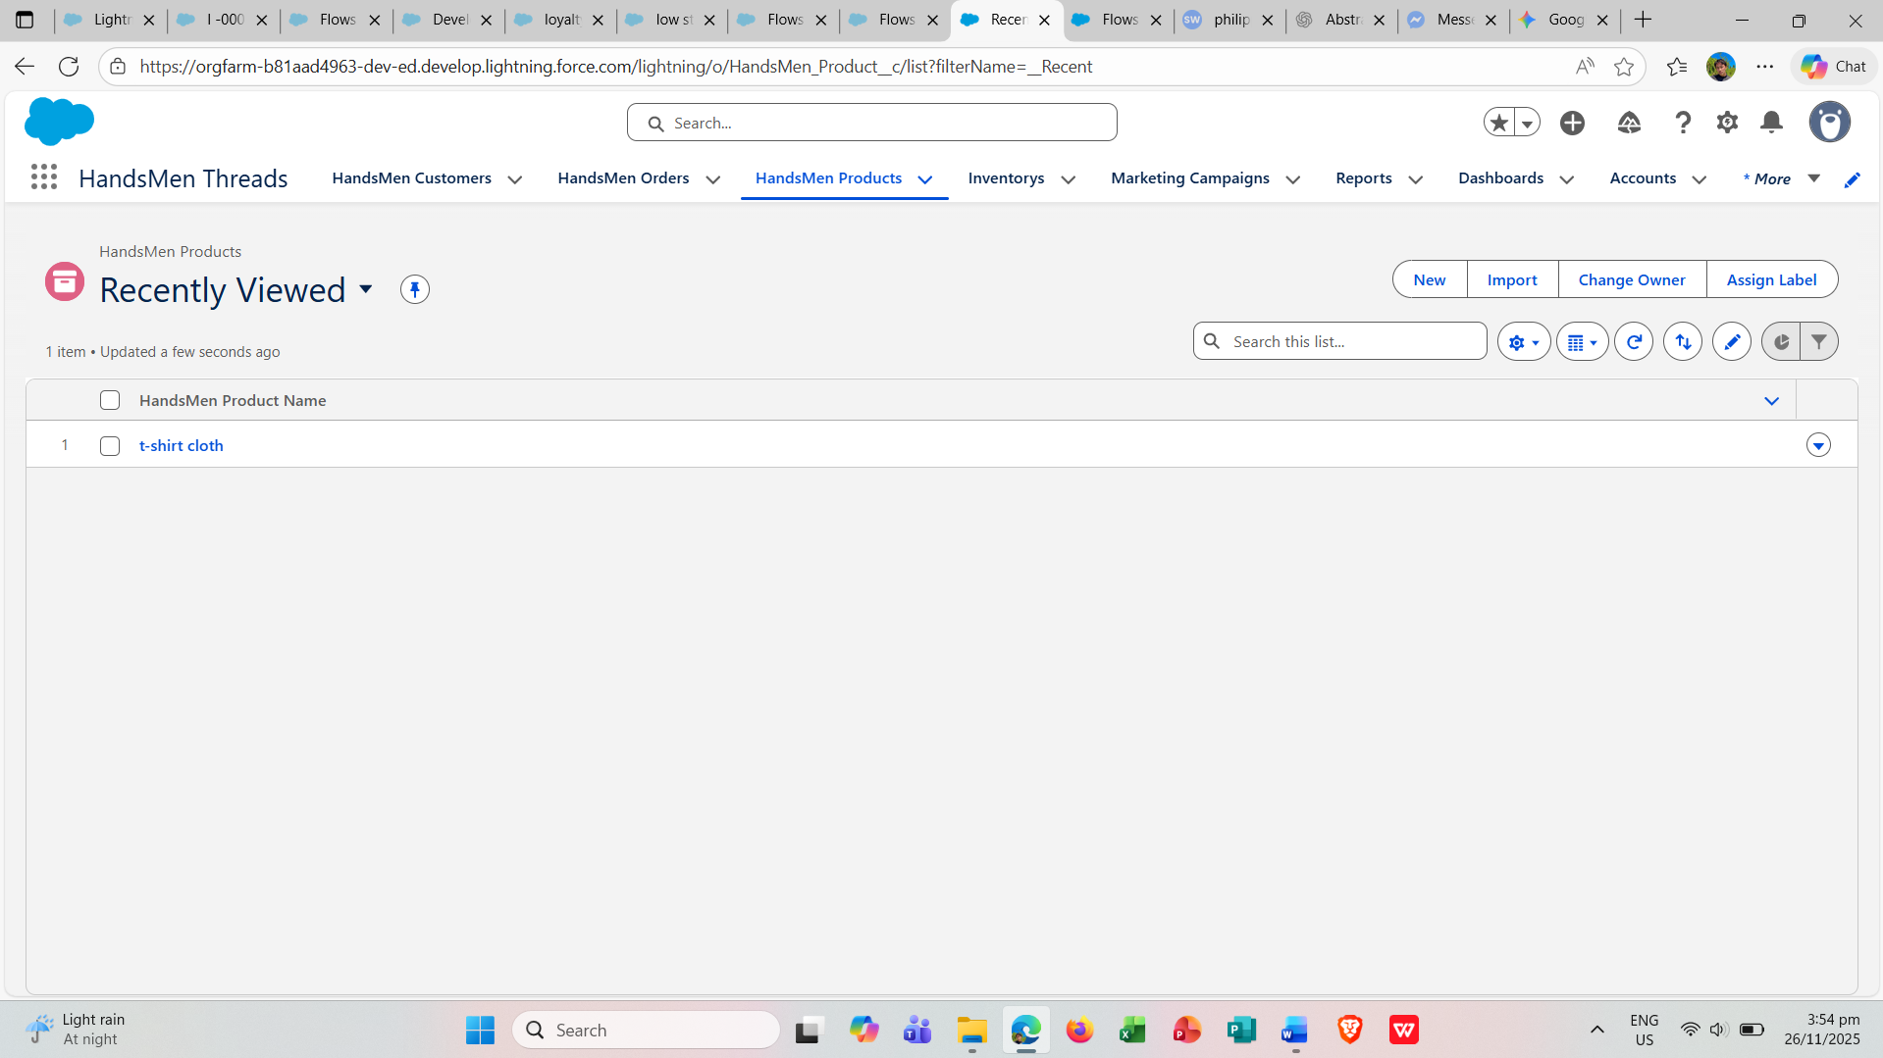

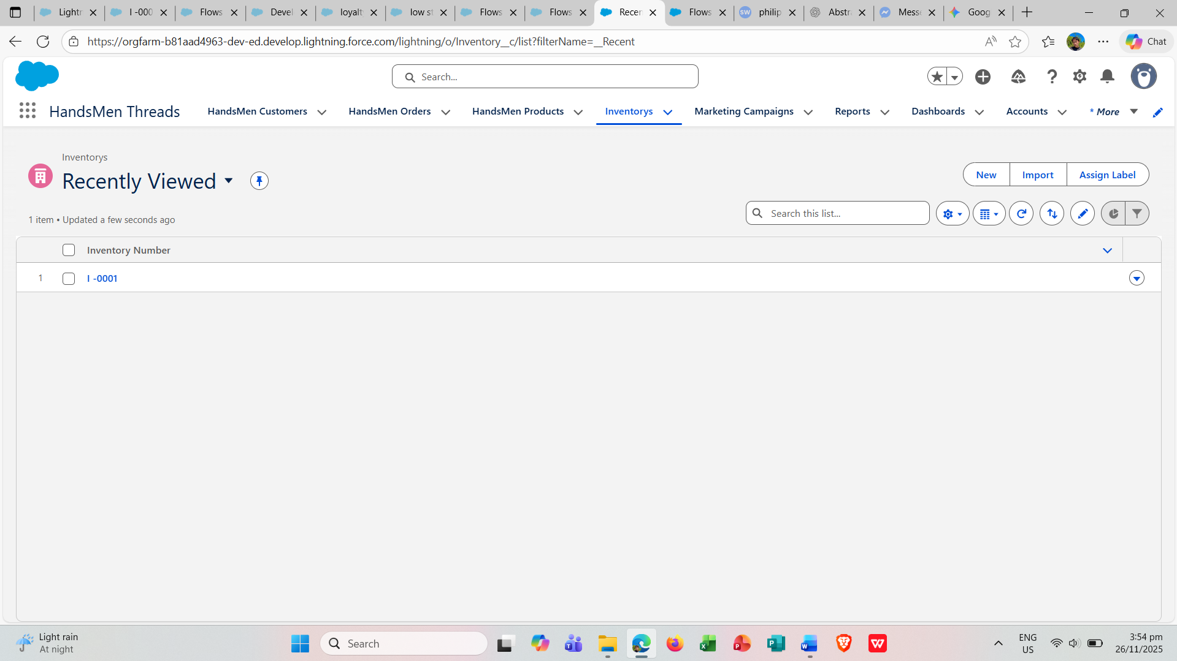

**Phase 4: Deployment & Training**

* The fully developed Salesforce CRM system was successfully migrated from the development environment to the production environment. Following deployment, the Sales, Inventory, and Marketing teams received training on the new features, workflows, and automation processes. Ongoing post-go-live support was provided to ensure smooth adoption and address any issues.

**Deployment Proof**

* An Apex Trigger was implemented to automatically update the **Total Amount** on Orders. The “Run All” function was executed on the Order Total Trigger to confirm proper operation.

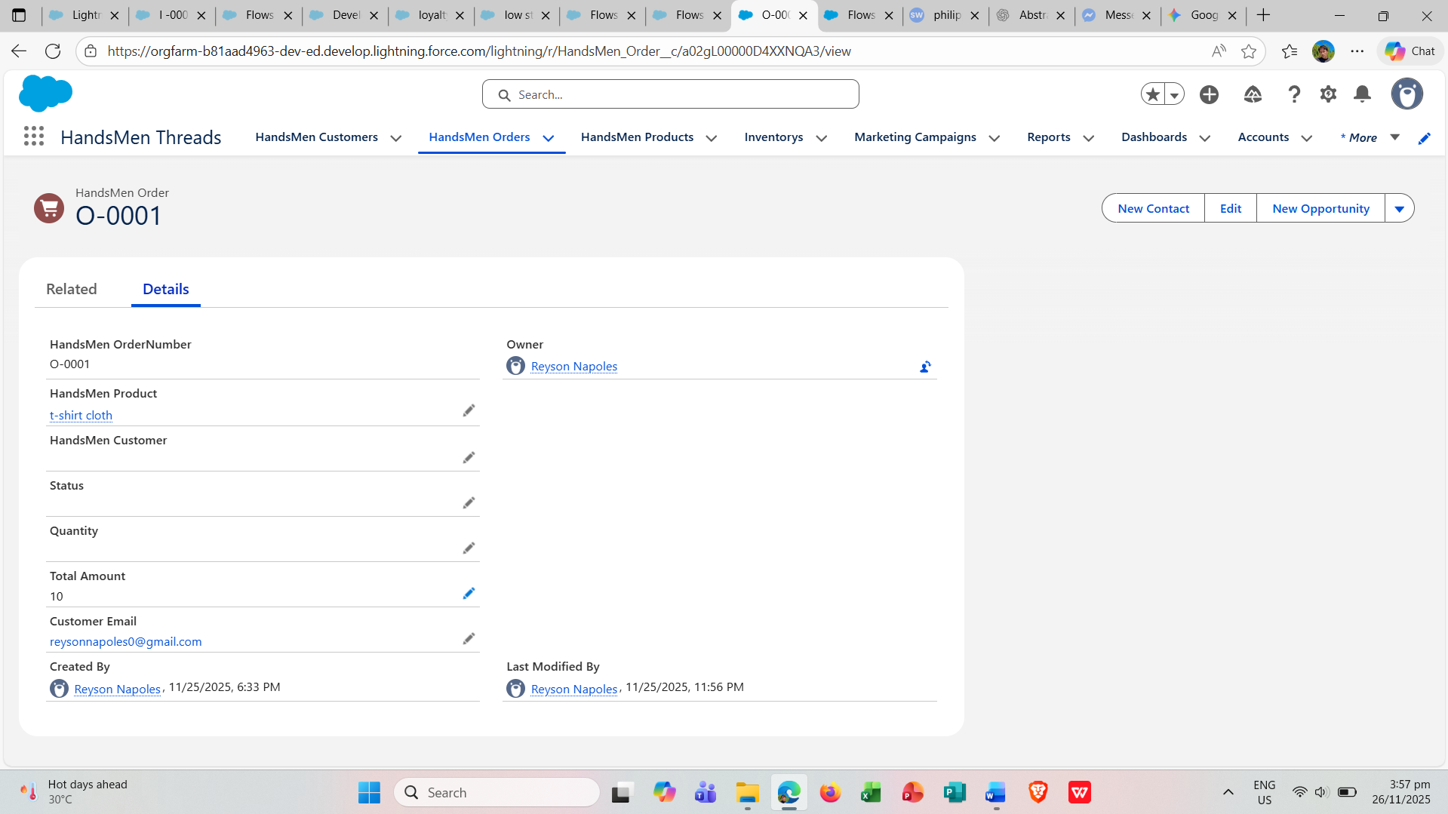

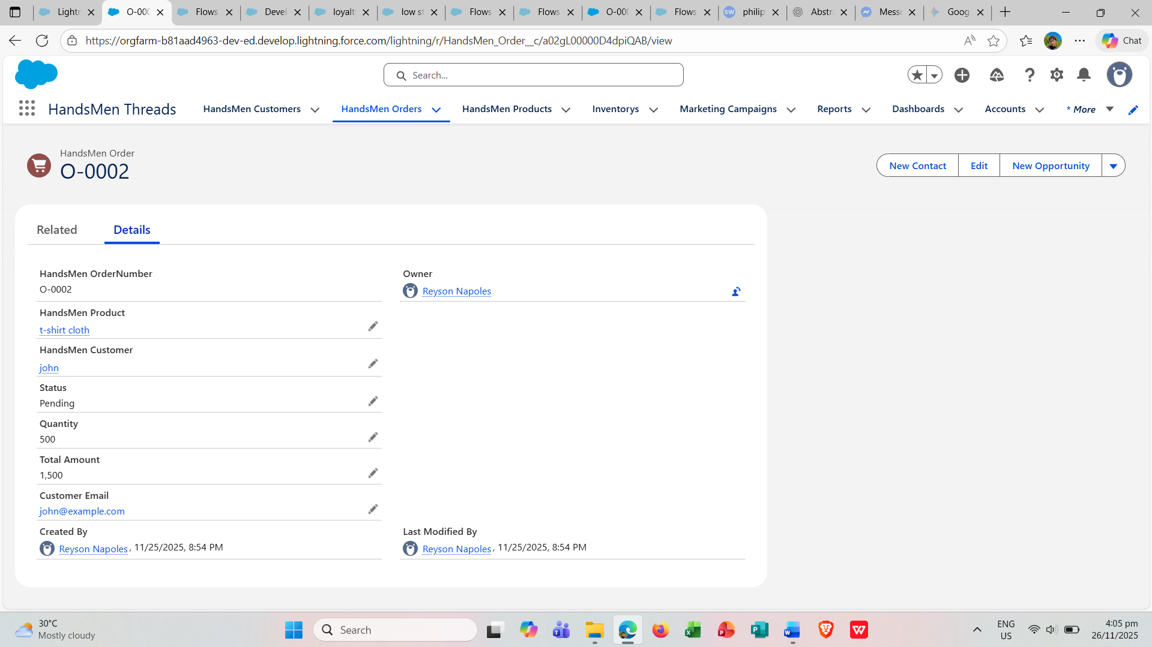

**Post-Deployment Automation Proof**

The system leverages an Email Template to perform the following automated tasks:

* Send an order confirmation email to customers whenever a new order is created.
* Automatically update product inventory whenever an order is created or modified.
* Run daily to update customer loyalty status based on total purchase amounts.

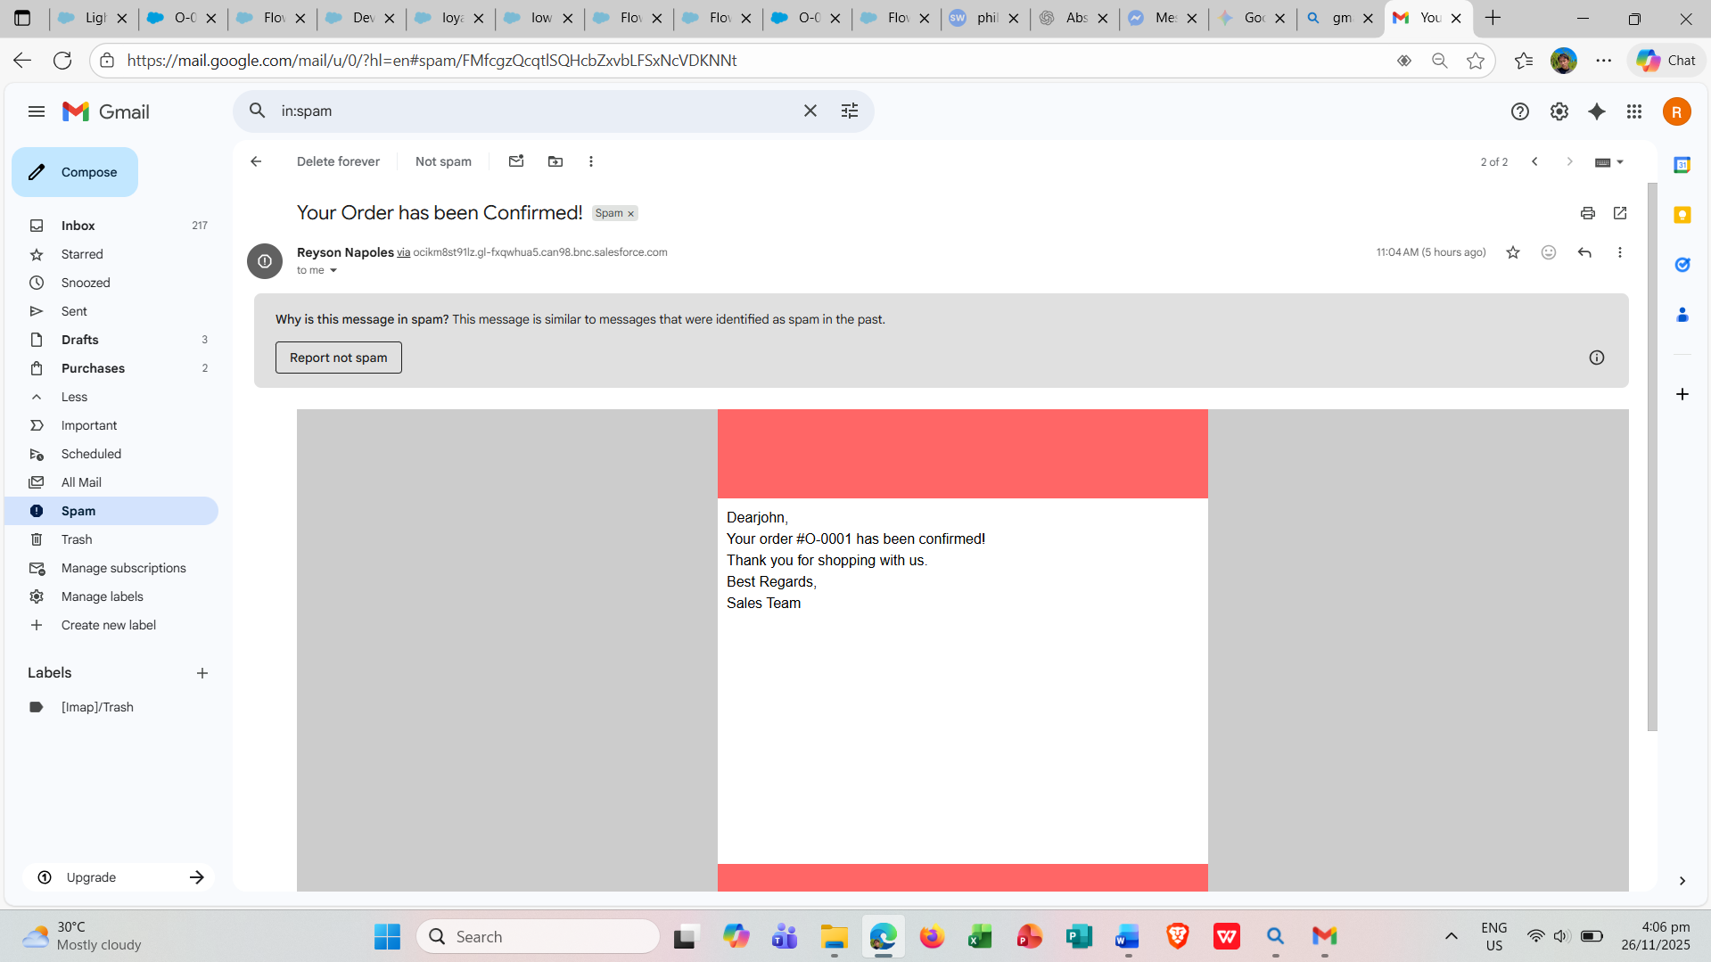

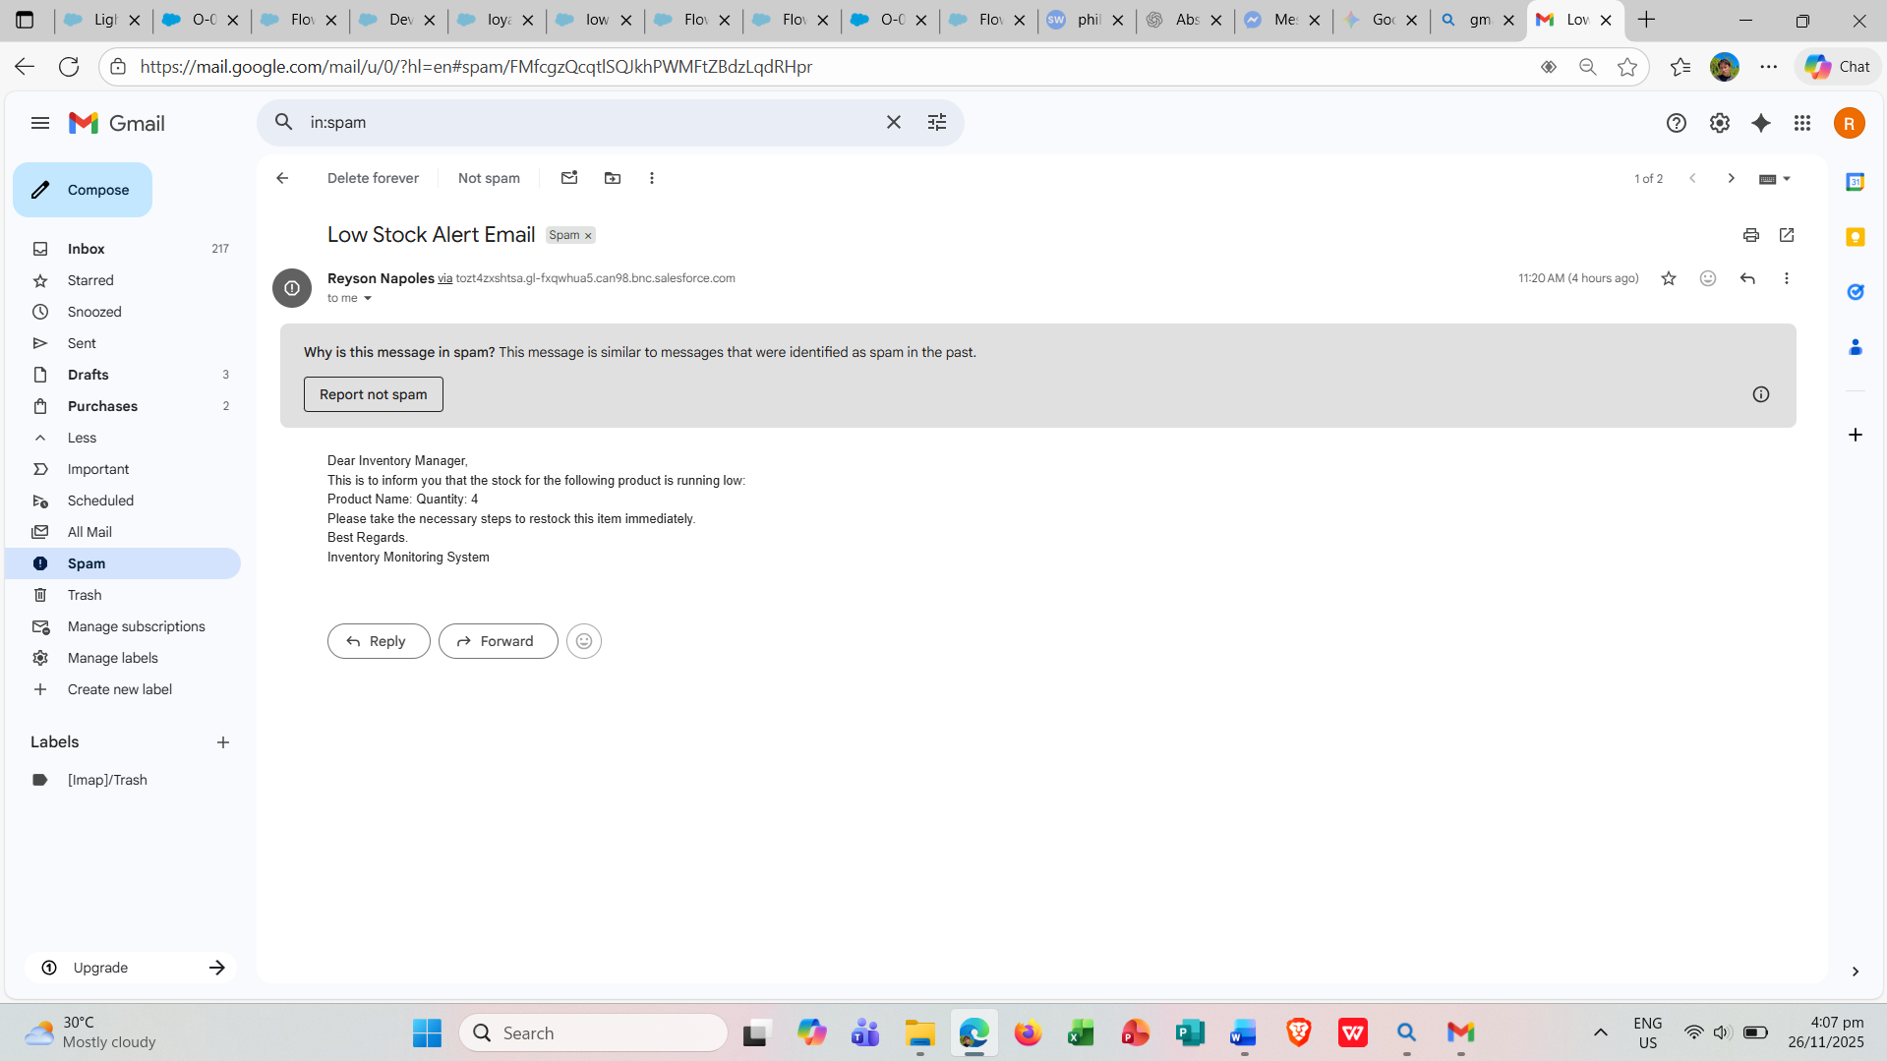

**CONCLUSION**

The HandsMen Threads CRM system, developed on the Salesforce platform, effectively optimizes critical business processes, encompassing customer management, product cataloging, order processing, inventory monitoring, and loyalty program automation. Utilizing Salesforce functionalities such as Custom Objects, Flows, Validation Rules, Email Alerts, and Apex, the system facilitates accurate data entry, ensures real-time updates, and enhances the overall customer experience. Furthermore, the implementation of automation and well-defined user roles reduces the potential for manual errors, accelerates operational workflows, and provides comprehensive insights into sales performance and inventory status.